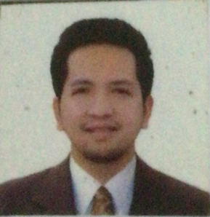
Your Name.
Address: 3529 Jeddah Street, Al Gharbi Hail, Kingdom of Saudi Arabia
Phone: +966-563678508
Email: bermie.baculao@yahoo.com
Skype or Zoom ID: 948 1559300
Marital status: Single
Number of children: 0
Ages of children: N/A
Birthdate: 06/06/1991

POSITION SOUGHT: Seeking for a job that utilize my knowledge and skills for the good of the company.

SUMMARY OF QUALIFICATIONS

- Currently more than 7 years working as a nurse (Emergency Nurse, Medical/Surgical Nurse, Occupational Health Nurse)
- Cum Laude
- Proven skills in Intravenous Insertion to all Ages.
- Demonstrated ability to identify and triaging patient's health condition and needs.
- Professional communication skills include fluency in English and Microsoft..

WORK HISTORY

Emergency Nurse 12-2019 to Present
Salamat Medical Group
Hail, Kingdom of Saudi Arabia

- Perform specialized life-saving treatments such as CPR, ACLS ,PALS, Adult and Neonatal Resuscitation.
- Evaluate and treat all injuries and illnesses in efficient and professional manner within the scope of practice and clinical nursing guidelines.

- Communicate with the doctors and other ER medical staffs fir the assessment, planning and intervention of the patient's treatment and management.

Medical/Surgical Nurse 10-2016- to 11-2019
Specialist Group Hospital and Trauma Center
Dagupan City, Philippines

- Applied nursing measures and techniques to patient medical diagnosis and therapy.
- Plans nursing care appropriate for the patient involving family and nursing assistant.
- Assists individual patients need
- Identify primary, secondary, tertiary preventions and health promotions.

EDUCATION HISTORY

Bachelor of Science in Nursing 2008-2012 2008-2012
Colegio de Sta Monica , Philippines

Certificates

Registered Nurse 2012
Professional Regulation Commission, Philippines

Prometric Registered Nurse. 2020
Saudi Council , Saudi Council

BLS, ACLS, PALS, IVT, Nasopharyngeal Swab, Canadian Visual Triaging

REFERENCES
- Dominic Barameda- 0500506496. infection control practitioner Salamat Hospital
- Chiselle Cirujales-0569534461. Colleague Salamat Hospital

