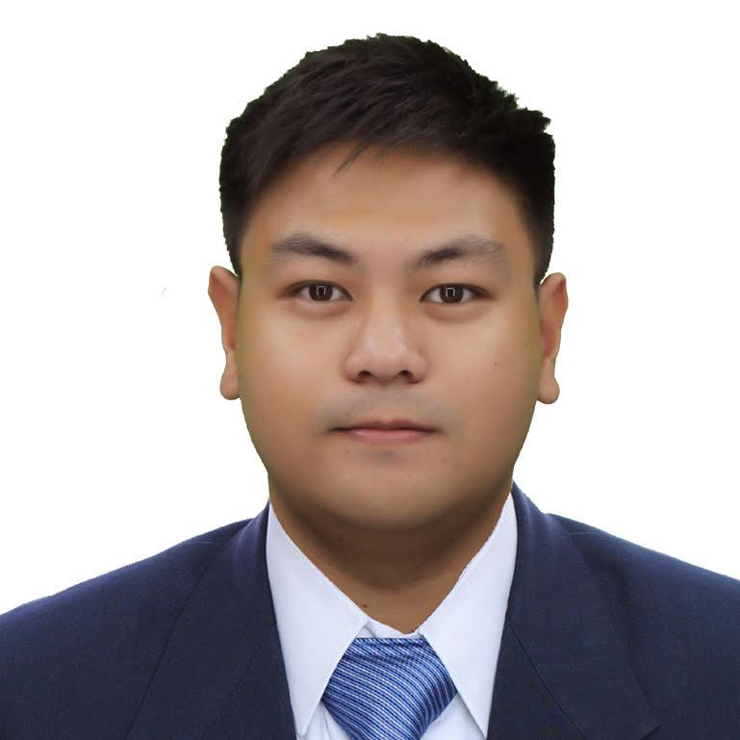
ALMIN MARK ALTRE
+639 164 190 553
altre.alminmark@gmail.com
Metro Manila, Philippines 1119

Determined and competent professional with experience in the hospitality and food and beverage industry, consistently aiming for a job with an excellent business where I can effeciently and effectively employ my skills and build up my potential.

PROFESSIONAL SKILLS
- Exceptional interpersonal and customer service skill
- Effective leadership skills and exercising organizational abilities
- Knowledge using point-of-sale programs like FoodPanda Delivery, and Grab Food
- Proficiency in food preparation, safety and sanitation practices
- Excellent time management ability
- Microsoft software literate
WORK EXPERIENCES AND ON-THE-JOB TRAININGS
- Filtrante Coffee | Present – Quezon City, Philippines
  - Supervisor
    - Oversee employees performance, provide guidance and support to each of the employees, and ensuring quality service to customers
- 7 Jewels Design n Construction | 2022-2023 - Pangasinan, Philippines
  - Project Supervisor
    - Oversee all aspects of a project from inception and completion, including people management.
- Lalamove | 2021-2022
  - Delivery Rider
    - Established excellent interpersonal skills with customers.
    - Transports and hands over goods to customers.
- Rustan Coffee Corporation, Starbucks Inc.| 2018-2021 - Quezon City, Philippines
  - Full-time Barista, Coffee Master
    - Receiving and arranging stock supplies
    - Maintained the company’s standards.
    - Demonstrated outstanding knowledge and skills about Starbucks coffee.
    - Positive and approachable manner of assisting customers with any concerns they encountered.
- Max's Restaurant | 2016-2017 - SM Fairview, Quezon City, Philippines
  - Trainee later on absorbed as a Dining Personnel
    - Completed 600 hours of training and demonstrated professional customer service Absorbed as Part-time/Contractual as Dining Personnel.
- The Manila Hotel | 2016 - Metro Manila, Philippines
  - Trainee
    - Gained 400 hours of training and observation at various sections of the Housekeeping Department.

EDUCATION
- Lyceum of the Philippines University | 2013-2017 - Intramuros, Manila, Philippines
  - B.S. International Hospitality Management, Hotel and Restaurant Administration
- Far Eastern University, Diliman | 2009-2013 - Diliman, Quezon City, Philippines
  - Secondary School

CERTIFICATES/SEMINARS/VISA
US Visa holder | Tourist 2022-2032
California Food Handler training | 2023-2026
Coffee Master | Starbucks Philippines, 2021
Partner of the Quarter Award | Starbucks Philippines, 2019
NCIII | Events Management - Technical Education and Skills Development Authority
NCII |Housekeeping - Technical Education and Skills Development Authority
NCII |Front Office - Technical Education and Skills Development Authority

