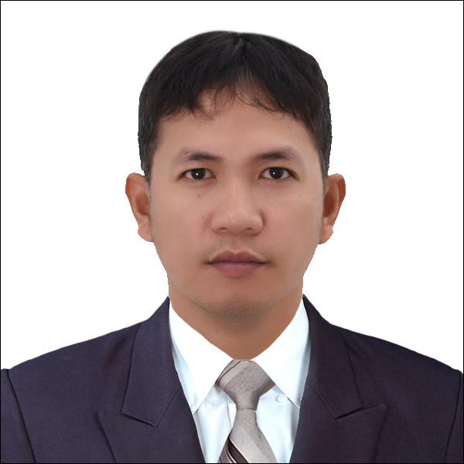
RYAN C. LOMIBAO
CNC MACHINE OPERATOR/ELECTRICIAN
lomibaoryan83@gmail.com

Birth Date |  | : | September 12, 1983 |  |  |  | Birth Place |  | : | Pangasinan
Age |  | : | 39 |  |  |  | Nick Name |  | : | N/A
Height |  | : | 5’7” |  |  |  | Civil Status |  | : | Married
Weight |  | : | 72 kg |  |  |  | Gender |  | : | Male
Passport No. |  | : | P8893636A |  |  |  | Religion |  | : | Roman Catholic
Date Issued |  | : | September 26, 2018
f
EDUCATIONAL INFORMATION
Education | School Year | School Name and Address | Course
Vocational | 2023 | Provincial Training Center-Urdaneta | Electrical Installation and Maintenance NC2
Vocational | 2018 | Youngjin Vocational School | Electrical Installation NC3
Vocational | 2017 | Youngjin Vocational School | C02 Welding
College - Undergraduate |  | Universidad de Dagupan (Formerly Colegio de Dagupan, Computronix College) | Information Technology
High School | 1996-2000 | Tandoc High School, San Carlos City Pangasinan | High School
Elementary | 1990-1996 | Sobol Elementary School, Asingan, Pangasinan | Elementary

EMPLOYMENT INFORMATION
Company : SEILSA
Address : Andong, Gimhae City, South Korea
Position : CNC Machine Operator
Date : May 15, 2015 – July 20, 2018
Contact Person : Mr. Park
Contact No : +82557249404

Duties and Responsibilities
- Check if there is enough oil, grease, and water coolant before operating the machine.
- Prepare and load raw materials and parts onto the machine.
- Prepare a test run to check if the machine produces outputs according to specifications.
- Set the machine to complete a full cycle of the product.
- Check the requirements of detailed part drawings into measurements for production.
- Replace all dull cutting tools if needed.
- Always check the measurement of the product to avoid rejected items.
- Ensure that every machine procedure is done in accordance with the strict guidelines of the company.
- Follow all company safety protocols.
- Inspect and clean the work area and machines used during the day before leaving at the end of the shift.

EMPLOYMENT INFORMATION
Company : Ace Co Ltd.
Address : Gimhae City, South Korea
Position : CNC Machine Operator
Date : March 24, 2014 – March 24, 2015
Contact No : +82553108147

Duties and Responsibilities
1. Check if there is enough oil and air pressure
2. Prepare and load raw materials onto the machine
3. Prepare a test run to check if the machine produces outputs according to specifications
4. Set the machine to complete full cycles to fabricate many products
5. Perform all work on machines with the help of a hoist and crane if required
6. Understand the specifications of the task at hand and the desired result by reading the blueprint
7. Always check the measurement of the product to avoid rejected items
8. Ensure that every machine procedure is done in accordance with the strict guidelines of the company
9. Follow all company safety protocol
10. Inspect and clean the work area and machines used during the day before leaving at the end of the shift.

EMPLOYMENT INFORMATION
Company : Ajusteel
Address : Gumi City, South Korea
Position : Dispatching Staff
Date : October 02, 2013 – March 10, 2014
Contact No : +82547143027
Website : http://ajusteel.com/html/main.html

Duties and Responsibilities
- Check the order list of items for shipment.
- Get the items and load them into the forklift.
- Used hoist crane if necessary.
- Safely load products onto containers
- Tie the items to ensure that they are safe during transit.
- Accurately document the receipt by making sure the delivery driver signed into the order lists.
- Report any incidents or unsafe conditions immediately.
- Ensure all safety controls are in place.
- Ensure compliance with environmental management and systems.
- Perform other tasks assigned.

EMPLOYMENT INFORMATION
Company : KUNKANG METAL
Address : Halim-Myun Gimhae City South Korea
Position : Press Machine Operator
Date : March 3, 2010 – January 14, 2012
Contact Person : Mr: Lee
Contact No : +821087782346
Duties and Responsibilities
1. Check if there is enough oil and air pressure
2. Prepare and load raw materials onto the machine
3. Prepare a test run to check if the machine produces outputs according to specifications
4. Set the machine to complete full cycles to fabricate a large number of products
5. Perform all work on machines with the help of a hoist and crane if required
6. Understand the specifications of the task at hand and the desired result by reading the blueprint
7. Always check the measurement of the product to avoid rejected items
8. Ensure that every machine procedure is done in accordance with the strict guidelines of the company
9. Follow all company safety protocol
10. Inspect and clean the work area and machines used during the day before leaving at the end of the shift.

EMPLOYMENT INFORMATION
Company : HANSUNG
Address : Andong, Gimhae City, South Korea
Position : CNC Machine Operator
Date : December 27, 2006 – January 30, 2010
Contact Person : Mrs. Kwak
Contact No : +82553259972
Website : http://www.hansungmc.com

Duties and Responsibilities
- Check if there is enough oil, grease, and water coolant before operating the machine.
- Prepare and load raw materials and parts onto the machine.
- Prepare a test run to check if the machine produces outputs according to specifications.
- Set the machine to complete the full cycle of the product.
- Check the requirements of detailed part drawings into measurements for production.
- Replace all dull cutting tools if needed.
- Always check the measurement of the product to avoid rejected items.
- Ensure that every machine procedure is done in accordance with the strict guidelines of the company.
- Follow all company safety protocols.
- Inspect and clean the work area and machines used during the day before leaving at the end of the shift.

SEMINARS AND TRAINING ATTENDED

Provincial Training Center-Urdaneta
Electrical Installation and maintenance
May 06, 2023 – June 15, 2023

Youngjin Vocational School, South Korea
Electrical Wiring Installation
March 11, 2018 – May 13, 2018

Youngjin Vocational School, South Korea
CO2 Welding
May 28, 2017– July 2, 2017

CAREER RELATED SKILLS
- Electrical Installation and Maintainance
- Forklift Operator
- CNC Machine Operator
- Welding
- Driving
- Crane Lifting Operator

LANGUAGES/DIALECTS
 | Speak | Read | Write
Filipino |  |  | 
English |  |  | 
Korean |  |  | 

CONTACT DETAILS
Mobile/Tel. Number : 0912-741-1540 / 0920-300-9733 (spouse)
Address : 267 Parayao, San Carlos City, Pangasinan 2420
Skype : N/A
Facebook Account : https://www.facebook.com/Ryan.ryan101010

RYAN LOMIBAO
Applicant

