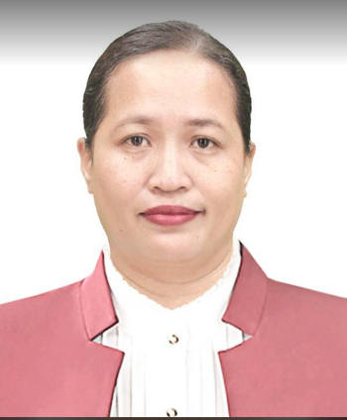
National Certificate Training
Mobile: +639175541173
Email : arianealvarez514@yahoo.com

Facebook: www.facebook.com/ariane26
Home Address: 738 Cabitoonan, Toledo City, Cebu
6038 Philippines
Link: @WPS
ARIANE M. ALVAREZ
My Skills and Work Attitude
Knows Microsoft Office, WPS, Open Office
Possess Analytical Thinking Skill
Team Leadership
Organize
Can work under pressure
Can work with minimal supervision

Pura S. Wagas - +63939 919 6287
Leah M. Cataposan - +639774947395
Glenda P. Labid - +639061509098

Character References
Work Experience
- Department of Education Toledo City Division (June 25, 2018 - Present)
-Mathematics Teacher -Classroom Adviser
- Scout Leader -Learners Information System Program Coordinator

- University of San Jose Recoletos - Balamban Campus
(June 1, 2012 - May 31, 2018)
-Student Welfare Coordinator -Drafting Technology Teacher
-Mathematics Teacher -Scout Leader

- Consolatrix College of Toledo City (June 1, 2007 - March 2009)
-Mathematics Teacher -Classroom Adviser

- SkillsUp Inc. (June 20, 2006 to May 30.2007)
- Account Executive

- Cebu Christian Institute International (June 1, 2005 - March 31, 2006)
-Mathematics Teacher -Classroom Adviser

Education Experience
- Cebu Normal University
Master of Science in Mathematics (2020 - Present)

- Cebu Normal University
Bachelor of Secondary Education major in Mathematics, Class of 2004
Member CNU Math Society

- Toledo National Vocational School, Class of 2000
Graduated 3rd Honorable Mention
Citizens Army Training Officer

- Fulgencio Dolino Elementary School, Class of 1996
Graduated 3rd Honorable Mention

Personal Summary
I’m a Secondary High School Mathematics Teacher with 14 years of teaching experience in the Philippines, seeking opportunities internationally, where I can apply my skills for continuous improvement.

Driver’s License
Land Transportation Office
License No. : G01-11-008076
Date of Validity : 10/31/2032
Place of Issuance : LTO Region VII

Teacher’s License
License
Professional Regulation Commission
License No. : 0861021
Date of Issuance : 11/25/2004
Place of Issuance : PRC Region VII

National Certificate Training
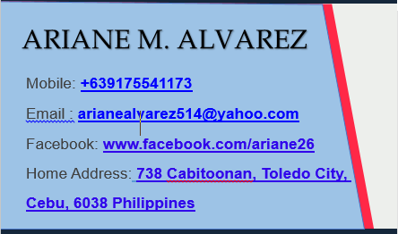

JOB DESCRIPTION
As Mathematics Teacher
- Prepare subject material for presentation and discussion according to curriculum.
- Prepare varied strategies to accomplish each learning competencies.
- Sourcing resources and supplies needed for the lesson.
- Prepare, administer and correct test with table of specification.
- Provide and correct student’s homework and quizzes..
- Participate in faculty meetings, subject area conferences (school learning action cell) and parent’s conferences.
- Attended educational conferences and teacher training workshops.
- Document students’ progress
- Evaluate the progress of students and discuss results with students, parents and school officials.
- Manage students’ behavior by establishing and enforcing rules and procedures.

As Classroom Adviser
- Prepare and update all necessary records, forms and documents accurately and completely as required.
- Track and maintain students’ progress in each learning area.
- Ensuring that the classroom remains safe and conducive to learning.
- Communicate necessary information regularly to students, colleagues and parents regarding student’s progress and needs.
- Perform all other related work delegated to accomplish the objectives of the total school program.

As Learners Information System Program Coordinator
- Issue the user accounts to all homeroom advisers and shall give them appropriate access rights to their specific homeroom sections;
- Ensure that the homeroom advisers shall update all required learners data for Beginning of School Year (BOSY);
- Update and submit all required school data for BOSY in the EBEIS;
- Ensure that the basis of the homeroom advisers in enrolling their learners into their section must be the School Form 1 (School Register);
- See to it that the homeroom adviser had registered transferees from private schools and Balik Aral learners who were enrolled in public schools in the previous years but do not have any LRNs yet after ensuring a thorough search in the system has been conducted
- Check the learner’s supporting documents (without LRNs) to the SDO, through the division Planning Officer III.
- Provide technical assistance to classroom advisers relation to LIS and E-BEIS concerns with the assistance of the Planning Officer III of the Division office;

As Student Affairs/Welfare Coordinator
- Develop, coordinate, and assess major events and activities in support of achievement of student learning outcomes. Coordinate project work flow, identify assignments, track progress, and ensure completion. Delegate tasks related to coordination of activities to other staff, students, collaborative partners and volunteers as appropriate.
- Provide information to students and staff regarding campus organizations and the opportunities available from the department.
- Ensure compliance of school organizations and students with rules, policies, procedures, and laws governing department functions.
- Actively attend and participate in weekly and monthly meetings of students and personnel.
- Develop and maintain effective communication and working relationships with administrators, staff, faculty, students, and community members within assigned and related projects.
- Collaborate with students, staff, faculty, and community members to work toward successful completion and assessment of the projects, events, and activities.
- Develop, prepare and conduct workshops, orientations, and other presentations. Assist in the coordination of training programs. Conduct presentations and department functions.
- Facilitate school tour to our Japanese and other Foreign Visitors from time to time
- Perform related duties as assigned.

JOB DESCRIPTION (continuation)
As an Account Executive
- Providing support for clients by learning about and satisfying their needs.
- Making calls or reaching out to prospects.
- Compiling and analyzing data to find trends.
- Maintaining a database of contact information.
- Building long-lasting, mutually beneficial relationships with external contacts and internal departments to create a better customer experience.
- Handling complaints and negotiations.
- Perform related duties as assigned.

LEARNING AND DEVELOPMENT (L&D) INTERVENTIONS / TRAINING PROGRAMS ATTENDED
- In-Service Training For Teachers
- Teachers Induction Program
- Training On Learning Delivery Modalities (LDM) 2 Course For All Teachers Under The Basic Education Learning Continuity Plan
- Teachers’ Training On Modular And Online Distance Learning
- Covid-19 Psychological First Aid (Pfa) And Mental Health And Psychosocial Support Services (Mhpss) For Teaching And Non-Teaching Personnel, Toledo City
- Updating Of End Of School Year Status Of Learners In The Learners Information system
- Spiritual Enhancement Program For Teaching And Non-Teaching Personnel
- Gender And Development Seminar For Newly Hired Teaching Personnel
- Content-Based In Service Training For Teachers
- TIP: A Step Towards Becoming A Proficient And Committed Teacher

AA

