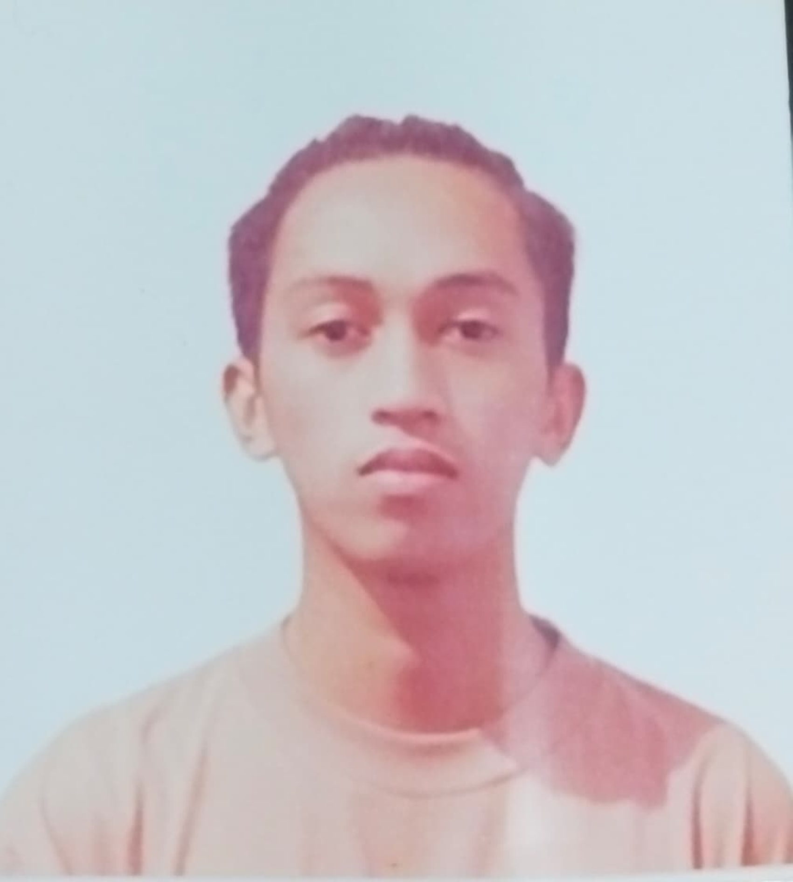
JOHN ANDREW VALERIO
LAURORA
  ^{CAREER OBJECTIVE}
  Seeking to leverage my skills and experience in a new role that challenges me to grow and contribute to the success of the organization.
  ^{EDUCATION}
  R. P. Cruz Elementary School |
  2010 – 2016
  Elementary
  Upper Bicutan National High School |
  2016 – 2017
  Junior High School
  ^{CONTACT DETAILS}
  Phone
  +63 997 267 2287
  Email
  flamundao@gmail.com
  Present Address
  05 Maguindanao Avenue, Purok 3, New Lower Bicutan, Taguig City
  Permanent Address
  35 Sampaloc Street, Purok 4, Lower Bicutan, Taguig City

