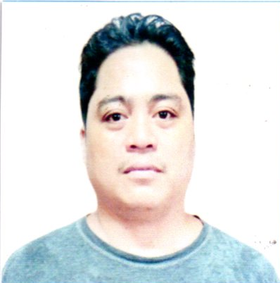
JOVIN R. ARAMBULO
Address: Janosa Binangonan, Rizal, Philippines
Contact Nos. : 09305733889/09667939039
E-mail Address: arambulojovin7@gmail.com

POSITION: DRIVER/OVERHEAD LINEMAN

WORK EXPERIENCE

1. M.G EXEO Network inc. Globe contractor
Elezabeth drive sta.ana sun valley bicutan taguig
POSITION:DRIVER/TECH.
October 27,2020 To 2021

2. FIBERHOME
19d rufino pacific tower,tower,6784 ayala avenue Makati city
Tell,+623 804-2854,804-2872

POSITION: DRIVER TECHNICIAN
October 31, 2018 – June 26, 2019
3. CCC COMPANY
RAS LAFFAN INDUSTRIAL QATAR

POSITION: WELDER (SMAW)
April 8, 2008 – December 2009

4. AL-BAHOOTH COMPANY
HAIL KINGDOM, SAUDI ARABIA

POSITION: OVERHEAD LINEMEN/STORE KEEPER AND FORKLIFT OPERATOR
June 29, 2012 – August 10, 2017

DUTIES & RESPONSIBILITIES:
• Troubleshooting and Maintenance of Overhead and Underground
Distribution
• Troubleshooting and Maintenance of Distribution Equipment
(Transformers, RMU, LV Panels, etc…)
• Connection and disconnection of KWH Meters.
• Constructions of Overhead and Underground Distribution Network
up 13.8 to 33 KV for Consumer Connection Electrification.
• Erection of Wooden Pole Steal pole & Stringing.
• Modify different assemblies of Distribution Construction Line.
• Responsible for the Replacement & Maintenance of Distribution
Equipment (Transformer, Lightning Arrester, Fuse Cut-Out, Load
Break Switch, etc…)
• Knowledgeable & Can install the following Equipment for Distribution
Constructions Line:
- Transformer
- Lightning Arrester
- Fuse Cut-Out
- Load Break Switch
- KWH METER
- CIRCIUT BREAKER

• Constructions of Overhead and Underground Distribution Network
Up-to 13.8 to 33 KV for Consumer Connection Electrification.
• Erection of Pole & Stringing.
• Modify different assemblies of Distribution Construction Line.
• Responsible for the Replacement & Maintenance of Distribution
Equipment (Transformer, Lightning Arrester, Fuse Cut-Out, Load, Break Switch, etc…)
• Knowledgeable & Can install the following Equipment for Distribution

- ELECTROWATT SYSTEM SERVICE CORPORATION
170 ML Quezon Street, Bagong Bayan, Taguig, Metro Manila

POSITION: OVERHEAD LINEMAN
April 7, 1999 – February 16, 2004

JOB DESCRIPTION:

- Attende training in the company on how to be a good behavior
- How to climb/install of street lights and trouble shoots electrical faults.
- Install post/suspension insulaton and other accessories/pole grounding.
- Pole erection/manual hole digging/stringing of HV conduction up to 33 KV/ as well as LV voltage conductions.
- Using ratchet cam-a-long sling also using of HV insulated stick to make cluster for earth connection.
- Using of load buster to open the line fuse cut out to make power interruption with o/h lines with big loads.
- Install Kwhr meters, Ct meters, and H.V. Ct metering
- Install of load brake Swith/Fuse cut Out, reclose, sectionalizer
- Installation of transformation, single phase and 3-Phase.

EDUCATIONAL ATTAINMENT

- Vocational Course: Concept Institute for Career Enhancement, Inc.
Gas Tungsten Arc Welding (GTAW) NCII
March 19, 2008

- Secondary: Janosa National High School
Janosa Binangonan, Rizal
1993-1997

- Primary: Janosa Elementary School
Janosa Binangonan, Rizal
1987-1993

PERSONAL DATA:

AGE : 43 years old
SEX : Male
WEIGHT : 80 Kg.
HEIGHT : 5'5"
CIVIL STATUS : Married
NATIONALITY : Filipino
RELIGION : Roman Catholic
BIRTHDATE : December 18. 1979

BIRTHPLACE : Janosa Binangonan Rizal

CHARACTER REFERENCES:

Romeo Gobres
Lineman
Al-Bahooth Company
0539339372

Ian Harvey Luna
Lineman
Al-Bahooth Company
Saudi Arabia
0539339375

Melvin Descalzo
Lineman
Al-Bahooth Company
Saudi Arabia
0539310118

I hereby certify that the above mention information are true and correct to the best of my knowledge.

Jovin R. arambulo
Applicant

