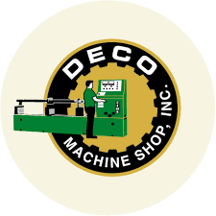
DECO MACHINE SHOP INC.
J.P. Cabaguio Avenue, Davao City, 8000, Philippimes
+63-82-226-4338 | www.decomach.com

C E R T I F I C A T I O N

June 22, 2023

To whom it may concern:

This is to certify that the employee with the below details is currently working in Deco Machine Shop, Inc. with business address in J.P. Cabaguio, Avenue, Davao City.

Name: Kenneth V. Espacio
Position: CNC Machinist
Department: Production Department

This certification is issued as a proof of his employment in our company.

MARIA CELESTE PANGANIBAN
Executive Vice President

