JOJIE MAGSINO HOLGADO
Address: Matingain 2, Lemery, Batangas
E-Mail: jojie.holgado@yahoo.com
Contact #: 0975-876-8646

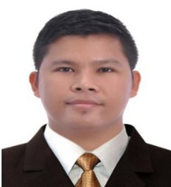

PROFESSIONAL SUMMARY:

To work as an Roof Plumber following the standards set by the company and supports its goals and objective through performing faithfully and loyalty to the duties and responsibilities I am assigned.

EDUCATIONAL ATTAINMENT:

Tertiary: Eulogio “Amang” Rodriguez Institute of Science and Technology
Bachelor of Science in Civil Engineering (2006 - 2012)
Nagtahan, Sampaloc, Manila

Secondary: Governor Feliciano Leviste Memorial National High School (2002 - 2006)
Igualidad St., Lemery, Batangas

Primary: Dayapan Elementary School (1996 - 2002)
Dayapan, Lemery, Batangas

PERSONAL INFORMATION:

Gender: Male Height : 5’9”
Age: 33 yrs. old Weight: 140lbs.
Date of Birth: January 11, 1990 Civil Status: Married
Place of Birth: Lemery, Batangas Religion: Roman Catholic
Father : Silvano Holgado Mother: Gloria Holgado

EMPLOYMENT HISTORY:

- Colorsteel Systems Corporation (Roofing)
Project Engineer (Batangas Branch) (March 2022- Present)
Engineering In-Charge (Batangas Branch)(Sept. 2016 - Nov. 2018)
Brgy. Del-Rosario, San Fernando City, Pampanga

- Topaz Industries Trading Corporation (Roofing)
Engineering Supervisor (Lipa Branch)
Technical Department (August 2019 - December 2020)
C. Raymundo Pasig City
- ACM Landholdings, Inc.
Site Administrator (Lipa Branch)
Property Management Group (December 2018 - July 2019)
105 CSJ Aguirre St., Legaspi Village, Makati City

- Philmetal Products Incorporation (Roofing)
Installation Engineer (February 2016 - August 2016)
Philsteel Tower 140 Amorsolo St., Legaspi Village, Makati City

- Puyat Steel Corporation (Roofing)
Project Engineer (May 2015 - February 2016)
Pasong Tamo Extension, Makati City

- Island Air Products Corporation (ISLAND GAS/LPG)
Assistant Plant Engineer/Production Controller (May 2012 - January 2015)
2933 Apelo Cruz St. Malibay, Pasay City

SPECIAL SKILLS:
- Computer literate (windows 7/Xp/Vista/, Excel PowerPoint , Autocad)
- Estimation, Site Inspection
- Can work with less supervision and can easily communicate with others
- Conduct Actual Measurement to Calculate the Quantities of Materials needed
- Install Sheet Metal Flashing
- Install and Repair Metal Roofs using hand and power tools
- Inspect problem of the roof to determine the best way to repair them
- Align roofing materials with edges of the roof
- Remove debris from roof to place materials
- Ensure roofs protect buildings from any weather condition
- Ability to work at heights
- Ability to handle and lift materials and tools
- Skilled at cutting roofing materials to fit around walls or vents
- Cover exposed nail or screw heads with roofing cement or caulk to prevent leakage
- Ability to accurately read and understand written materials and instructions
- Follow safety rules
- We install different kinds of Galvalum (oven bake Annealed Zinc 45% Aluminum 55%) steel roofs such as follows:
*Tile roofing profile
*Ribtype
*Corrugated
*Metal Framing
*Wall Cladding
*Steel Decking
*Ceiling

SEMINARS ATTENDED:

Construction Occupational Safety and Health (COSH)
Synerquest Management Consultancy Services Inc.
40 Hours
August 05 - 26, 2017

Steel Basics Program
Colorsteel Systems Corporation / San Fernando Pampanga
September 19 - 24, 2016
40 Hours
March 24 – 26, 2022

Roof Framing Technical Training
Colorsteel Systems Corporation
8 Hours
December 05, 2022

Electrical and Fire Safety Training
Jolize Safety Training Center
8 Hours
August 20, 2023

CHARACTER REFERENCES: Request on Demand

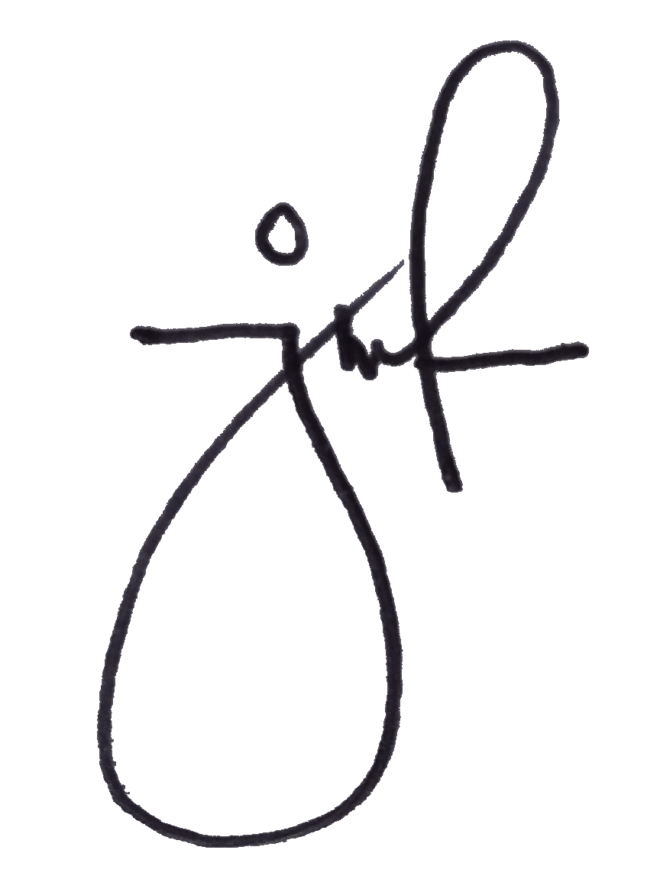
I hereby certify that the above information is true and correct to the best of my knowledge and beliefs.

Jojie M. Holgado
Applicant’s Signature

