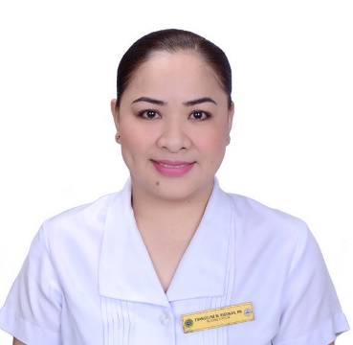
CURRICULUM VITAE

Name : Evangeline Rigonan
Phone : +639274831888
E-Mail : vanzrigonan26@gmail.com

PERSONAL DETAILS

Date of Birth : 02/26/1984
Nationality : Filipino
Gender : Female
Marital Status : Married
Religion : Roman Catholic
Height : 162 cm
Weight : 68 kg
BMI : 25.9
Permanent Address : 34 Marcos St. Barangay 9 San Aglipay, City of Batac,
Ilocos Norte, Philippines 2906
Languages Known : English, Filipino, and Iloko

PASSPORT DETAILS
Passport No. : P6223756B
Place of Issue : DFA ILOCOS NORTE
Date of Issue : 02/03/2021
Date of Expiry : 02/02/2031

EDUCATIONAL DETAILS

College/University Attended : Mariano Marcos State University, City of Batac, Ilocos Norte
Qualification : Bachelor of Science in Nursing
Graduation Date : 04/04/2006

REGISTRATION DETAILS

Registration Authority : Professional Regulation Commission
Registration No. : 0456401
Registration Date : 11/19/2007
Validity Date : 02/26/2025

Registration Authority : Colorado Board of Nursing
Registration No. : 1687471
Registration Date : 01/30/2023
Validity Date : 09/30/2023

EXPERIENCE SUMMARY

Name of Employer : Mariano Marcos Memorial Hospital and Medical Center
Bed Capacity : 200
Area of Exposure : Medical Surgical Ward Pay
Out Patient Department
Medical Infectious Ward
Medical Ward
Medical Oncology Ward
Medical Surgical Ward Pay
Medical Surgical Isolation

Cases Handled : Congestive Heart Failure, Myocardial Infarction, Stroke,
Bronchial Asthma, Chronic Obstructive Pulmonary Disease,
Chronic Kidney Failure, Cancer, Coronary Artery Disease,
Diabetes Mellitus, Hepatic Encephalopathy, Hyperthyroidism,
Hypothyroidism, Liver Cirrhosis, Anemia, Leukemia,
Pneumonia, Peptic Ulcer Disease, Seizures, Shock, Angina
Pectoris, Hepatitis, Pulmonary Tuberculosis, Gastritis,
Hypertension, Kidney Stones, Meningitis, Tetanus, Covid-19 Positive, Appendicitis, Cholecystitis, Systemic Lupus Erythematosus,

Position : Nurse III/ Head Manager
Duration : 07/01/2022 to Present

Duties and Responsibilities
- Performs direct nursing care procedures which include bedside nursing, hygiene, pre and post-operative nursing care, and admission and discharge duties.
- Observes, records and reports patient’s symptoms, conditions, and progress of treatment and therapy.
- Prepares patients for, and assist physicians with, diagnostics and therapeutic procedures for both normal and specialized treatment cases.
- Carry out doctor’s order within an acceptable time frame.
- Administers medication.
- Administers blood transfusion.
- Sets up treatment trays and prepares instruments and treatment.
- Maintains records reflecting patient condition, medication, and treatment.
- Assist in the education and rehabilitation of patients and their families relate to physical and mental health.
- Coordinates with other sections in the hospital regarding patient care.
- Monitors performance of staff by determining performance efficiency ratings and reviewing with them the procedures and techniques in service delivery
- Collaborates with other department of the hospital to align nursing activities with other services
- Conduct researches and studies to identify opportunities to improve the nursing service
- Monitors the adequacy and maintenance of medical supplies and equipment
- Checks important documents such as daily time records of personnel and patient hospital records for completeness and accuracy, and consolidates weekly, monthly and quarterly reports of hospital output

REFERENCE

- Felicitas C. Bolusan
Administrative Officer IV
OIC- Human Resource Management Office
Mariano Marcos Memorial Hospital and Medical Center
+639084385970
hrmss.mmmhmc@gmail.com

