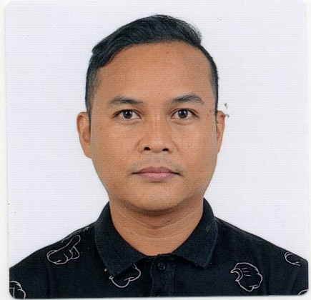
WILLIAM I. TOMANENG, JR.
843 Sniders Highway, Apt 305, Walterboro, SC 29488, USA
+18435996207/+971567746460
wtomaneng@gmail.com
Birthdate and Place: November 22, 1980, Philippines
Civil Status: Single
Citizenship: Filipino

Career Objective:
To obtain a role as an elementary teacher in an interactive and educational manner to all students of all ages
Qualifications:
- 5 years teaching in the United States of America
- 15 years teaching experience in the Philippines teaching Math, Science, English
- School Paper Adviser teaching Journalism from 2005 - 2018
- Experience teaching with American Curriculum
- Bachelor’s Degree in Elementary Education
- Masters in Educational Management major in Educational Leadership
- PhD student
- Passed the Philippines Licensure Examination for Teachers 2001
Skills:
- Effective teaching and learning methodologies
- Excellent classroom management and time management
- Strong written and oral communication
- Proficient in digital learning
Work Experience
- 5th Grade Teacher – August2018 to June 2023 at Colleton County School District, South Carolina USA
- Elementary Teacher – October 2003 to August, 2018, at Department of Education, Quezon City, Philippines
Trainings:
▪ Teaching and Learning in Multiple Learning Environments - Classroom Teachers (February South Carolina USA 2021)
▪ How to Effectively Communicate with Students & Parents in the New Structure of Learning (September 2020, South Carolina USA)
▪ Breakthrough School Improvement Process (February 2020, South Carolina USA)
▪ Climate, Culture and Expectations Through PBIS and Curriculum Mapping (June 2019, South Carolina USA)
▪ New Tech Practices (February 2019, South Carolina USA)

References:

Tasheena Allen/Kayla Baker Janis Headden
Principal/Assistant Principal Director of Elementary Education
Cottageville Elementary School Colleton County School District
+18437824528 +18437824510

