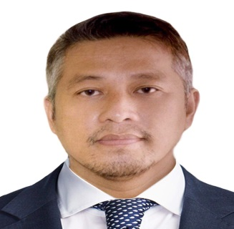
DENVER T. PUNONGBAYAN
#58 Rivera St. Barangay Progreso
San Juan City Philippines
Cell.no. +639950819360
ver2usmagnvs@gmail.com

OBJECTIVES: Seeking a new career in butchery with reputable organization in which my experience can be a positive influence on the expansion of the company.

SKILLS AND QUALIFICATIONS:

* Completed training in Slaughtering operation (Swine) NCII
* Can perform evisceration
* Flexibility and Adaptability
* Physical Strength and Endurance
* The Ability to Always Learn New Things

WORKING EXPERIENCE:

THE MARKETPLACE SHANGRI LA December 2022 – Present Butcher/Merchandiser
RUBLOU
*Deboning, cutting, grinding and preparing meats for sale
*Cleaning and maintaining tools and equipment
*Ensuring displays and signage are accurate and attractive.
*Weighing, packaging, pricing, and displaying products.
*Keeping records, budgets, and inventory.
*Performing quality inspection and food safety on meats and other products.

VARGAS MEAT SHOP MAKATI April 2021- December 2022 Butcher/ helper
*Prepare meat for cutting
*Cleaning Offal
*Cleaning and sanitize shop after shift

SYNERGOS CONSTRUCTION INC. PASIG 2019 -2021 Company driver
*Safely transporting company staff as well as various products and materials.
*Adjusting travel routes to avoid traffic congestion or road construction.
*Providing accurate time records of the company vehicle’s coming and goings.
*Keeping the company vehicle clean and properly maintained.

TOP DEAL INC. SAN JUAN 2016-2019 Company driver
* Worked as part of a commercial organization to deliver goods all over San Juan city.
* Communicating with managers and admin officers to make them aware of any issues,
and problems regarding deliveries.
* Working to very tight deadlines and helping colleagues if required.

P.L AGUILA INC.MFG. SAN JUAN 2014-2016 Truck driver
* Update work log daily and track all deliveries.
* Maintain vehicle by checking oil, gas, fuel, tire pressure and cleanliness.
* Utilize heavy equipment to move the goods.
* Ensure the vehicle in a good condition.
* Helps to load and unloading the vehicle.
* Presented bills and receipts and collect payments for goods delivered.

HUGO TAPAS and GRILL SAN JUAN 2012-2014 Delivery driver
* Done driving with various types of vehicles.
* Responsible for keeping vehicle in good condition.
* Responsible for marketing.
* Organizing the loading and delivery of parcels within tight time limits.
* Communicating with managers and clients.
* Making a positive impact into the success of the business.

EDUCATION:
LAS PIñAS EAST NATIONAL HIGH SCHOOL DIPLOMA.

