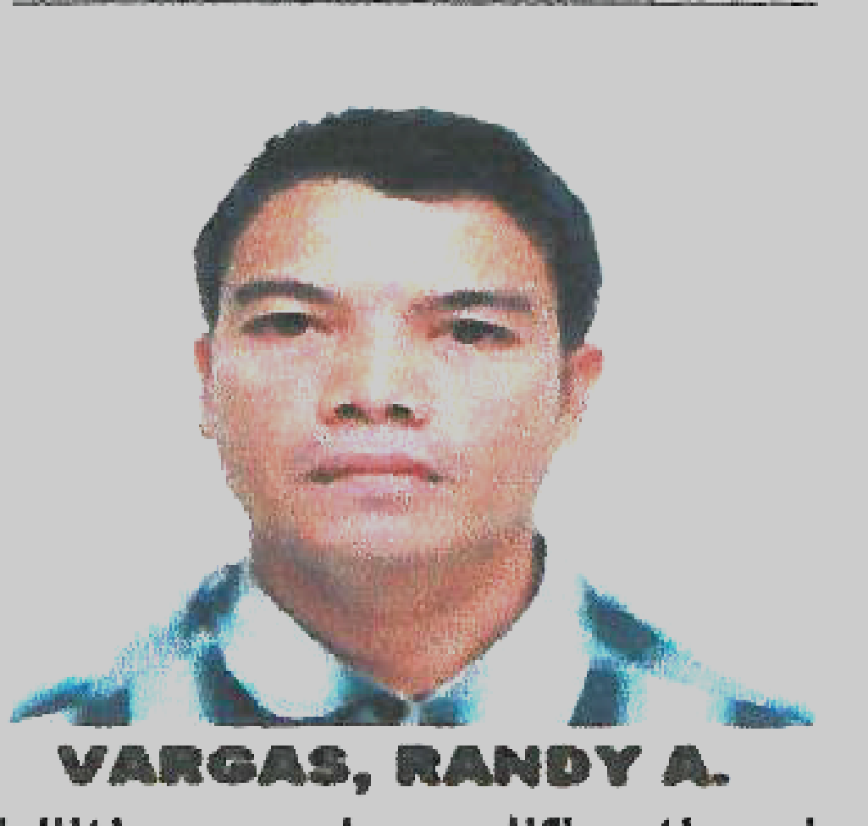
RANDY A. VARGAS
Bisal, Manaoag, Pangasinan 2430
Mobile No: +966546259008
+639959325606
Email Add: randyvargas219@yahoo.com
randyvargas575@gmail.com
Skype ID: Randy Vargas

OBJECTIVES: To be able to acquire position that will best fit of my capabilities and qualification in order to utilize and demonstrate my capabilities, talents and skills necessary for the enhancement of my career and the task I may be assigned to in addition, to contribute for the development of the organization and also to embrace new methodologies and strategies for career growth.
______________________________________________________________________________

PERSONAL INFORMATION : Date of Birth: April 03, 1980
Birth Place: Meycauayan, Bulacan
Civil Status: Married
Nationality: Filipino
Language Dialect: English/Filipino and (mother tongue)

EDUCATIONAL ATTAINMENT:

COLLEGES: Associate in Computer Science
Metro Dagupan Colleges
Serafica St. Mangaldan, Pangasinan, March 2012

SOLAS Basic Training
Pangasinan Merchant Marine Academy
Dagupan City

SPECIAL AWARDS: Certificate of Distinction (OJT) ASCS, Computer Harware Troubleshooting

ELIGIBILTY: Certificate of Competency, Computer Hardware Servicing NC-II TESDA

VOCATIONAL: Computer Hardware Servicing NC-II TESDA
Capitol, Lingayen, Pangasinan

Electricity Building Wiring and Motor Control
Happy Hearts Foundation in Cooperation of PSU
Mangaldan, Pangasinan

Basic Electronics
Mangaldan, Pangasinan

SECONDARY: Manaoag National High School
Manaoag, Pangasinan, March 2001

ELEMENTARY: Manaoag Central School
Manaoag, Pangasinan

WORK EXPERIENCE:

Company: Softline Contracting Est./Exchange Market
Position: Sales Associate/Cashier/Shipment Receiver/Forklift Operator
Related Work: Customer Services, Receiving payments and issuing receipts, Merchandiser.
Duration: September, 2021 to 2022
Company Address: Al Kharj, Saudi Arabia

DUTIES: Responsible for assisting customers throughout the buying process , My duties include greeting customers when they enter the store, helping customers find specific products or showing them how to use them and ringing up customer purchases on the POS register. Also unpacks delivery shipments and compares packing lists to purchase orders, ensuring accurate deliveries. They also package products so that they can be shipped back out. A Receiving Shipment removes packing materials or stock items from their inventory. Also unloading stocks from truck container

Company: Saudi Glass and Aluminium Company
Position: Storekeeper/ Fabricator Helper
Related Work: SAP User, Storekeeper, Assembler Materials and Supplies Receiver,
Forklift Operator
Duration: January, 2021 to August 2021
Company Address: Riyadh, Saudi Arabia

DUTIES: A Warehouse Storekeeper responsible for receiving, storing, ordering, and issuing supplies and equipment. Position assists with the daily operation of supply services which include distributing supplies and equipment for the school division. Position also acts as the Supply and Logistics Supervisor in his or her absence. Also driving forklift to unloading stocks shipment from the truck container.

Company: Manaoag National High School
Position: Supply Non-Teaching Assistant
Related Work: Computer Operator, Materials and Supplies Receiver
Duration: January, 2020 to January 2021
Company Address: Manaoag, Pangasinan, Philippines

DUTIES: Maintains supply inventory; verifies inventory levels by checking shelves, notifies supervisor as to replacement needs or places orders as appropriate. Orders, receives, and stores supplies in warehouse or supply room. Reviews incoming order forms for proper coding, quantities requested, and authorized approvals; inspects and verifies supplies received against invoice and packing slip; initiates requests for vendor corrections. Locates stock and delivers requested items to authorized departments.
Contacts approved vendors to reorder routine supplies; processes paperwork related to supply requests, including small purchase orders, purchase requisitions, and check requests.

Company: Tamimi Market
Position: Inventory Control Clerk, Forklift Operator
Related Work: SAP User, Storekeeper, Computer Operator, Materials and Supplies Receiver
Duration: March, 2017 to 2019
Company Address: Riyadh, Saudi Arabia

DUTIES: Responsible for performing receiving with products from local to international goods, responsible for making purchase orders from incoming vendors orders and restocking supplies. Also driving forklift to unloading stocks shipment from the truck container. Maintaining and updating records.
Counting materials, equipment, merchandise or supplies in stock. Reporting discrepancies between physical counts and computer records Distributing or stocking merchandise. Receive and inventory stock.
Other various tasks as assigned.

Company: Hadi Dammam/Saudi Aramco
Position: SAP User, Admin clerk
Related Work: Office Paper Works, Computer Operator, Materials and Supplies Receiver
Duration: September, 2013 to 2015
Company Address: Jubail, Saudi Arabia

DUTIES: Responsible for performing clerical and administrative duties in an office setting. Assists executive assistants and secretaries by sorting mail, filing, answering phones, greeting clients, scheduling meetings, and restocking supplies. handles the receiving of items in a warehouse or backroom of a store, and ensures that the shipments are inspected, sorted and stored in the warehouse or stocked on shelves as needed

Company: Manaoag Central School SPED Center
Position: Administrative Aide/Maintenance Worker
Related Work: Carpenter, Mason and Electrician
Duration: September, 2004 to September 2009
Company Address: Manaoag, Pangasinan, Philippines

DUTIES: Builds or repairs cabinets, doors, frameworks, floors, or other wooden fixtures used in school buildings, Checking all electrical wiring's installed in all classrooms, systems, and fixtures in buildings. Installs conduits and pipes to rooms electrical wires and cables. Checking circuit breakers and other electrical hardware installed in all classrooms and offices. Helping and assisting in building layout, framing, sheathing, and roofing structures

Company: Sterling
Position: Inventory Staff
Related Work: Supplier Inspection, Item Encoder, Forklift Operator
Duration: 2003 to 2004
Company Address: Meycauayan, Bulacan, Philippines

DUTIES: Compiles and maintains records of quantity, type, and value of material, equipment, merchandise, or supplies stocked in establishment: Counts material, equipment, merchandise, or supplies in stock and posts totals to inventory records, manually or using computer. Records purchases, maintains database, performs physical count of inventory, and reconciles actual stock count to computer-generated reports. Receives, unpacks, and delivers goods; re-stocks items as necessary; labels shelves. Processes and/or approves invoices for payment.

Company: Solid Development Corporation
Position: Production Operator
Related Work: Maintenance, Machine Cleaner, Operator
Duration: 2002 to 2003
Company Address: San Ildefonso, Bulacan, Philippines

DUTIES: Responsible for operating and maintaining complicated machinery. Work in a dedicated capacity specializing in a single machine or class of machines. Also responsible for monitoring, maintaining and operating warehouse equipment. They are also responsible for cleaning and quality-checking their machinery to ensure everything works as it should.

Company: Cosmos Bottling Corporation
Position: Production Operator
Related Work: Bottle Processing, Machine Operator, Maintenance
Duration: September, 2001 to 2002
Company Address: San Jacinto, Pangasinan, Philippines

DUTIES: Tends beverage inspection machine, equipped with photoelectric cell that automatically detects and rejects filled beverage bottles containing solid impurities: Starts conveyor that conveys bottles filled with alcoholic or nonalcoholic beverages through inspection machine.

COMPUTER SKILLS:

- Proficient in Windows Operating System and Microsoft Office Application
- Skilled and Trained in Computer Troubleshooting
- Can work with or without supervision in school and office work
- Can fix and Troubleshoot for any computer operation hardware and software problems

LEADERSHIP AND AFFILIATION:

- Active Member of School Organizations.
- Alumni President (Batch 2011-2012), Metro Dagupan Colleges
- Member of SBP and FIBA Basketball Referee’s Association

SEMINARS/CERTIFICATION/TRAININGS/WORKSHOP ATTENDED:

- 38th Eastern Pangasinan Council Jamborette, Poblacion, Laoac, Pangasinan
- Quality, Productivity and Employability Enhancement Seminar, Metro Dagupan Colleges, Mangaldan, Pangasinan
- SBP/DEBRA Recruitment and Refresher Course on FIBA Rules 2012, Dagupan City, Pangasinan
- Region I Information and Communications Technology (ICT) Congress in the Ilocos Region, Diego Silang, Capitol of La Union San Fernando
- Division Seminar Workshop on Gender and Development, Urdaneta City, Pangasinan
- One Day Division Seminar Workshop on Service Records Updating and Management for Elementary and Secondary District Clerk/School Clerk Personnel in the Division of Pangasinan II, San Fabian, Pangasinan

SKILLS:

- Computer Literate
- Electrician
- Carpentry
- Masonry
- Welder
- Driving
- Inventory Analysis
- Picker Packer
- Microsoft Office User
- Forklift Operator

AVAILABLE DOCUMENT:
Passport Number: P8705561B Expiry Date: January 14, 2032 Place of Issue: Philippine Embassy (Riyadh, Saudi Arabia) Date of Issue: January 15, 2022. Seaman Book Passport Holder,
Postal Identity Card: 4246786 Expiry Date: 10-11-16 Place of Issue: Manaoag, Pangasinan

CHARACTER REFERENCES:

ERNA C. NEBRAN, Ed.D.
Contact No. +639454663586
District Supervisor
DEPED, Manaoag District

JUAN L. SANCHEZJ
Contact No. 0491703534899
Email Add. Sanchezjl@aafes.com
PSAB U.S Exchange Faicility Manager
Saudi Arabia

ROMAE R. DE ASIS, Ed.D.
Metro Dagupan Colleges, President
Mangaldan, Pangasinan

JAIME S. APRESTO, Jr.
MDC College Instructor
Mangaldan, Pangasinan

MOHAMMED HANIF
Contact #+966507945271
Tamimi Market L.L.C.
Saudi Arabia

I hereby certify that the above information is true and correct to the best of my knowledge and belief.

_______________________________
RANDY A. VARGAS
Applicant

