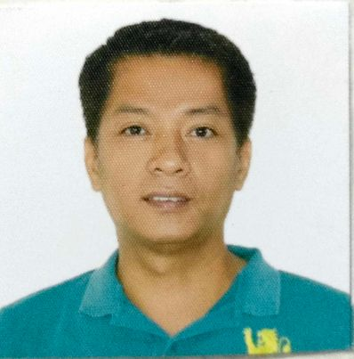
RAMCIS K. PALABASAN
14 APOLLO III STREET. MOONWALK VILLAGE
BARANGAY TALON SINGKO
LAS PINAS CITY.
CONTACT # +639810033041/+639065736362
EMAIL@ ramciskpalabasan@yahoo.com

OBJECTIVES/PROFILE:

Secure a responsible career opportunity to fully utilize my training and skills, while making a significant contribution to the success of the company

EDUCATIONAL BACKGROUND:

COLLEGE : HOLY CROSS COLLEGE
Sta. Ana. Pampanga.
April 08, 2011
Bachelor of Science in Commerce
Major in Management

HIGH SCHOOL : MANGA CACUTUD HICH SCHOOL
Cacutud, Arayat, Pampanga.
March 27, 1997

ELEMENTARY : MANGA CACUTUD ELEMENTARY SCHOOL
Cacutud, Arayat, Pampanga.
March 1993

WORK EXPERIENCE:

- EZE-DAPH WOOD AND STEEL INSTALLATION SERVICES
107 Dr. Sixto Street, Barangay Rosario, Pasig City
April 2015-Present
CONTRUCTOR/GENERAL MANAGER/OWNER

- A.S KABIGTING CONSTRUCTION
1657 Dapitan St, Sampaloc< Metro Manila.
April 2007-2015
TIME KEEPER/PURCHASER/ELECTRICIAN/DRIVER/INSTALLER

- MEDICAL REPRESENTATIVE
Sigart Pharma Corporation
316 JIAO Building #2 Timog Avenue,
Cor, Quezon Avenue, Quezon City.
September 01, 2004 – September 30, 2006

- Sales Man of the Month
1st Runner up - January 2006
1st Runner up – February 2006
2nd Runner up – March 2006
1st Quarter Champion Sales Man – 2006

- Area Covered Central Luzon
Pampanga
Bataan
Olongapo
Lower Tarlac
Lower Nueva Ecija
Bulacan

- SALES REPRESENTATIVE
RBW Marketing
Sindalan, San Fernando, Pampanga.

- Area Covered
Pampanga
Tarlac
Bulacan

- SALES CREW (SC)
Bench Body
SM City, Pampanga
San Fernando Pampanga
November 19, 2003 – April 19, 2004

- SALES UTILITY CLERK (SUC)
Sm Appliance Center
SM City, Pampanga
San Fernando, Pampanga.
September 25, 2002 – February 25, 2003

- SERVICE CREW
Quantum Amusement Corporation
SM City, Pampanga.
San Fernando, Pampanga.
April 2001 - September 2001
March 2002 - August 2002
May 2003 – October 2003

SEMINARS:

- GOOD MANAGEMENT TROUGHT HUMAN RELATION
Partyland, San Fernando , Pampanga
February 24, 2000

- Career Planning Workshop
Holy Cross College, Sta. Ana, Pampanga
March 27, 2001

SPECIAL SKILLS:

Computer Literate, Filling Documents, Driving, Contraction Design, Carpenter,
Electrician, Businessman

PERSONAL INFORMATION:

Ager : 43 years old
Birthdate : September 27, 1980
Birthplace : Guemazan, Arayat, Pampanga.
Civil Status : Married
Religion : Roman Catholic
Citizenship : Filipino
Sex : Male
Height : 5’9”
Weight : 180 lbs
Father’s Name : Roman Palabasan
Occupation : Deceased
Mother’s Name : Gloria Palabasan
Occupation : Housewife

CHARACTER REFERENCE:

- ETHEL BALATBAT
Holy Cross College Advised
Sta. Ana, Pampanga
+639276920338

- ALMA OCAMPO
Quantum Amusement Manager
SM City, Pampanga
San. Fernando, Pampanga
+639185394937

I hereby certify that the above information is true and correct to the best of my knowledge and belief.

____________________________
Ramcis K. Palabasan
Applicant

