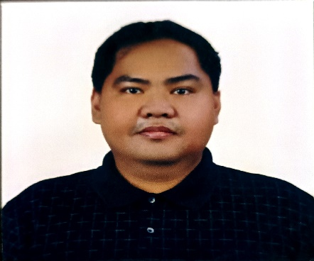

NOMER R. ROSARIO
San Juan, San Carlos City, Pangasinan
Phone No: 0961-578-9087
Email Address: nomerrosario2@gmail.com

Career Objective

To provide healthcare services to my fellow citizen using my knowledge in medical science and acute sense of medical analysis. To gain experience and enhance my abilities while serving the less fortunate.

PERSONAL INFORMATION:
Date of Birth: August 24, 1992
Place of Birth: San Carlos City, Pangasinan
Age: 30 years’ old
Height: 5’7 ft.
Nationality: Filipino
Gender: Male
Marital Status: Married
Religion: Roman Catholic
Residence: San Juan, San Carlos City, Pangasinan

Key Skills

- Eager to learn
- Commitment towards caring for patients
- Excellent listener
- Skilled at interacting with patients in a friendly manner
- Empathetic and courteous
- Capable of accepting responsibilities towards patient's health and well being
- Capable of performing under pressure

Educational Qualifications
- Completed Bachelor in Science in Biology from Virgen Milagrosa University Foundation in the year 2012
- Completed Medicine from Virgen Milagrosa University Foundation in the year 2016
- Achieved Doctor of Medicine from Professional Regulation Commission last September 2017

Work Experience

1. Completed Medical Clerkship at Virgen Milagrosa Medical Center, San Carlos City, Pangasinan, from 2015 to 2016.
These was some of my responsibilities:
- Perform preliminary examination
- Fill up the medical charts
- Provide first aids
- Observe and assist in procedures
- Observe and monitor the patient's state of health during and after the treatment
2. Completed Medical Internship at Region 1 Medical Center, Dagupan City, Pangasinan, from 2016 to 2017.
These was some of my responsibilities:
- Administer medicines and vaccinations
- Perform Minor Surgeries and procedures such as suturing, circumcisions, NSD’s with supervision of the residents
3. Resident on Duty in Jesus Healing Hands hospital in Rizal St. Poblacion Urbiztondo Pangasinan January 2018 up to June 2022. Currently moonlighting.

Extracurricular Activities
- Completed Basic Life support training under The Philippine Red Cross
- Attended many medical missions, majority in remote barangays
- Attended seminars

Character Reference

Dr. Frances Therese E. Bachar
Medical Director at Jesus Healing Hands Hospital
0918-945-5027

Ms. Cynthia P. Magleo
Chief Nurse at Virgen Milagrosa Medical Center
09953290557

