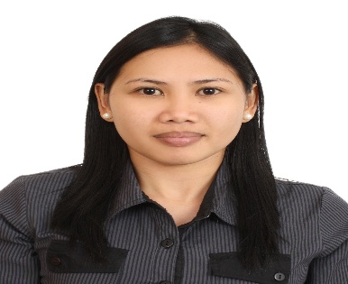
MARIA GRETCHEN L. RESURRECCION
Address: 39 Sta. Rosa, Laoag City, Ilocos Norte, Phils.
Mobile no: +639121124060
E-mail: resgretchen16@gmail.com

High organized, confident, have the ability to inter-act well with people and possess a pleasing personality

WORKING EXPERIENCE:

Store Manager
Kookee House Inc., Elizabeth Place
Brgy. 11 Sta. Balbina Laoag City, Ilocos Norte
April 02, 2020-present

Kitchen Supervisor
Max’s Restaurant
Brgy. 11 Sta. Balbina Laoag City, Ilocos Norte
May 08, 2016- April 01, 2020

Cashier
Vigan Foods Corporation (Franchisee of Red Ribbon Bakeshop)
Brgy. 1 San Francisco, San Nicolas, Ilocos Norte
November 2015- April 2015

Sales
DRH Hospitality Group
Dubai UAE
April 09, 2013- March 2015

Administrative /Service Crew
Vigan Foods Corporation (Franchisee of Red Ribbon Bakeshop)
Brgy. 1 San Francisco, San Nicolas, Ilocos Norte
February 2007- October 2013

EDUCATIONAL BACKGROUND:

VOCATIONAL SICES Philippines, Inc.
Live-in Caregiver
June 2010- January 2011
NC II Certificate in Caregiving

COLLEGE Data Center College of the Philippines
Associate in Computer Secretarial
2005-2006

Mariano Marcos State University
College of Business Economics and Accountancy
Bachelor of Science in Economics
2002-2004 (under graduate)

PERSONAL INFORMATION:

Nickname : May
Date of Birth : December 21, 1984
Citizenship : Filipino
Status : Single
Sex : Female
Height : 5’0
Language : Filipino & English

I hereby certify that the above statement is true and correct.

MARIA GRETCHEN L. RESURRECCION

