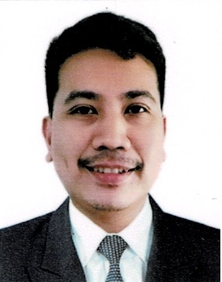
CHRISTOPHER E MAYOR

P E R S O N A L S K I L L S
P R O F I L E

Exremely motivated to Good communication skills
constant develop my skills and Successful working in a team
grow professionally. I am environment as well as independently
confident in my ability to come The ability to work under pressure
up with more practical skills and and multi-task
to generate more opportunities The ability to follow instructions and
by providing health care for deliver quality result
holistic well being. Patience and flexibility
C O N T A C T W O R K E X P E R I E N CE

Address: 0011 Sitio Buntong Kanlungan Ni Maria
Palay Brgy. San Juan Antipolo Home for the Aged Inc.
City 92 Mangga Dr. Nayong Silangan Subd.
Email: toffee_christucker@ Brgy. Dalig Antipolo City 1870
yahoo.com May 2020
Cp no: 090360517590 Responsibilities:
E D U C A T I O N Assist in household chores where they
assigned.
Provide tender loving care for elderly
AMA CLC LEARNING CENTER Monitor vital signs of the elderly
Computer System Tech Assist the elderly in feeding and bathing
Class of 2001 Providing perenial care to the elderly
Accompany elderly to their medical
AMA COMPUTER COLLEGE appoinments.
BSIT Interact with the elderly
Class of 2009 Spending time with the elderly by sharing
stories,playing games,or assisting them in
AJB TRAINING CENTER their hobies
Care Giving Course Do other works as maybe required from
NCII Certified time to time
- 2022

T R A I N I N G S Upson International Corp.
A T T E N D E D 747 Romualdes Street, Ermita
Manila
OFFICER IN CHARGE
Philippine Heart Association Feb. 2003- up to present
Philippine College of
Cardiology Analyze the product line being carried
BASIC LIFE SUPPORT with Develop and foster team spirit and team
AED Training working habits,facilitate my team’s
July 2022 effeciency,ensure that team goals
are achieved and that high standards are
Bleeding Control Course sought and maintained.
July 2022 Monitor strictly that proper attendance
and punctuality are being observed at all
AJB TRAINING CENTER times
Basic Nursing Skills in Monitor in and out of the stocks
Physical Care Aide Specialization Check that all weekly inventories have
July 2022 been accurately counted
Oversee the store’s daily cash/ check
C H A R A C T E R sales collection
R E F E R E N C E S Monitor and review monthly sales
attainment
Delegate each task effeciently and
Jason Adriano monitor each team performance
Area Manager
Upson International Corp.
Ermita Manila
09209609376

Archie Prado
HR ADMIN
Kanlungan Ni Maria
Home for the Aged Inc.
09664819082

