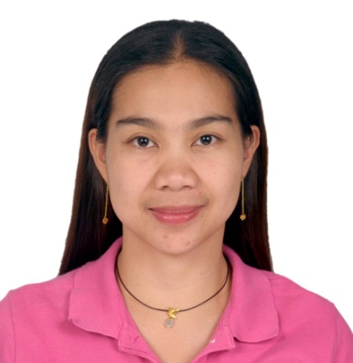
CATHERINE V. PASCUAL
Address: Marawi Camiling, Tarlac 2306
Contact Number: +639177673455
Email: deverapascualchatheirain@gmail.com

Objective:

To be part of company, to improve my knowledge and skills and to secure position that is appropriate for my qualifications which develop my professional and personal growth. I can be more efficient for what task being assigned to me.

Skills:

Ability to work with detailed oriented, enthusiasm to learn, full pledge cooperation, strong communication skills, dedication to work, responsible, ability to adjust different situation, self-motivated and willing to undergo training. Assertive, optimistic, flexible, with strong determination to succeed. Fast learner, both hard and smart worker. Good Leadership ability and creative.

PERSONAL INFORMATION:

Date of Birth : May 21, 1980
Place of Birth : Ramos, Tarlac
Age : 43 years old
Sex : Female
Civil Status : Single
Religion : Roman Catholic
Nationality : Filipino
Height : 5’4
Weight : 60kg.
Father’s Name : Rolly G. Pascual
Occupation : Farmer
Mother’s Name : Rosita V. Pascual
Occupation : Retired Midwife (RHU Camiling)
Spoken/Language : Tagalog, English, Mandarin and Ilocano

EDUCATIONAL BACKGROUND:
Tertiary : University of Baguio, Baguio City
B.S. Computer Engineering
06/1997-10/2001

Secondary : Saint Rose Catholic School
Paniqui, Tarlac
06/1993-04/1997

Elementary : Marawi Elementary School
Marawi Camiling, Tarlac
06/1987-03/1993

WORK EXPERIENCE:

Technical Staff
Philend Lending Investors Inc.
Baguio, City

Duties and Responsibilities:
*MIS, MARKETING AND FINANCE

Call Center Agent
Sutherland Global Services
Tarlac, Philippines

Marking Production Operator
SILICONWARE PRECISION INDUSTRIES LTD. (SPIL)
Taichung, Taiwan

Testing Production Operator KING YUAN ELECTRONICS CO. (KYEC)
Chunan, Taiwan

LINGSEN PRECISION IND. LTD.
Taichung, Taiwan

Duties and Responsibilities:
*Operate machine (Greatek) manual ink, Laser
*Monitoring Machine Status and execute machine command
*Check material number/magazine number/quantity
*Inspect material if the position of marking on the product is
in the required direction
*Maintain a high quality product before shipping out to customer

Executive Secretary(Real Properties)
YOSHITAKA SAGAMI REAL PROPERTIES
Makati, Philippines

Duties and Responsibilities:
*Assisting clients call, walks in and corporate clients
*Responsible for all the incoming and outgoing accounts in the branch
*Responsible for preparing sales invoice and official receipt to the clients
*Perform other duties from time to time

Admission Records/Clerk(Hospital)
SALVADOR GENERAL HOSPITAL (SGH)

Duties and Responsibilities:
*Assisting patient when they arrive at the hospital and record their
personal information
*Prepare birth certificate, death certificate and medical certificate
*Handling patient's records

CHARACTER REFERENCES:
Available Upon Request

I hereby certify that the above information are true and correct to the best of my knowledge and belief.

CATHERINE V. PASCUAL

