Curriculum vitae
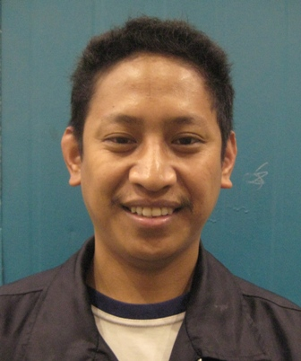
Mobile: 09278576189
+639456513960 (Phil)
Address: Banaba, San Pascual, Batangas
Philippines 4204
E mail Add: liamkyle_aldovino@hotmail.com

LINO NORIEGA ALDOVINO
Position: CNC Machine Operator

WORK SUMMARY:
Flexible and resourceful machine operator who has maintained perfect attendance and safety records throughout my eighteen years career in structural company. Experience in operating plasma cutting and drilling machine, beam drilling and cutting machines.
EMPLOYMENT HISTORY
Company Name |  | : Zamil Steel Industries
Position Title |  | : CNC Machine Operator
Date Joined  Location Project  Project |  | : April 11,2004 up to present  : Dammam, Kingdom Saudi Arabia  : Structural Steel and Pipe Rack
Machine Able to Operate :
PLATE PROCESSING MACHINE
- Machine Punch and Plasma ( Peddinghaus)
- Plate Cutting Machine ( Oxy Acetylene)
- Plate Cutting and drilling Machine
- KALTENBACH Drilling and Plasma
- KALTENBACH Beam Drilling
- KALTENBACH Band Saw Machine

Contact Person : Marlon Balasta
Maintenance Supervisor / Electronics
+966508992480

DUTIES AND RESPONSIBILITIES:

- The operator is responsible for the quality and quantity of the finished product.
- Clean the machine at the beginning and end of the shift.
- Check the coolant and hydraulic oil levels in the machine and the hydraulic power pack unit.
- Maintain the machine in good working condition.
- Collect the PO and check the availability of the required program in the computer.
- Check the Required Raw Material availability with foreman.
- Process the components as per the P.O.
- Record the daily production data in the Machine Log Sheet.
- Check the routine mechanical and Electrical conditions of the machine.
- Inform the foreman in case of machine breakdown or any other maintenance related problem in the machine.
- Read manufactures operating manual and strictly follow all operation and safety rules specified in the manual.
Company Name | : GREATECH Phil. Inc.
Position Title | : CNC Machine Operator
Date : March 25, 2002 – March 26, 2004
Location : FCIE, Brgy Langkaan I, Dasmarinas Cavite
Project : Precision Machining, Dieset, Jigs & Fixtures
Automation System and Metal Works
Machine Able to Operate :
- Milling Machine
- Mitsubishi Machining Center ( M-V5C)

Duties and Responsibilities

- Ensure the condition of machine before and after work.
- Ensure accuracy at all times specially in dimensioning material / item
Such as have tolerance.
- Ensure quality and Productivity at all times.

Other Skills
  - Overhead Crane Operator
  - Material Checker

Educational Backround
College | : Batangas State University (former PBMIT) | 1997 – 2001
Secondary | : Banaba West National High School Banaba  West,  Batangas city | 1993 - 1997
Elementary | : Banaba Elementary School Banaba San Pascual  Batangas | 1986 – 1993
Course | : Bachelors of Industrial Technology

Personal data
Age | : 42 years old | Date of birth |  | : August 18, 1980
Nationality | : Filipino | Gender |  | : Male
Marital status | : Married
Permanent Residence | : Banaba,San Pascual, Batangas

I hereby to certify that above information are true and correct thru the extent of my knowledge.
_______________________________
Signature

