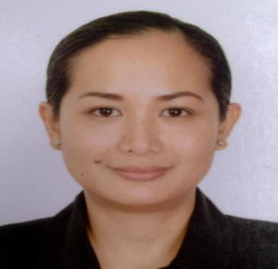

RHODA RIVERA-MALAPITAN
Lot 10-A, Zone 4, Prk. Pepsi, Brgy. Bata, Bacolod City
Negros Occidental 6100, Philippines
Tel. no. (+6334) 700-4050
Cel. no. (+6334) 9363852041
- mail Address: shyni20@yahoo.com

- PERSONAL BACKGROUND

- Sex: Female
- Civil Status: Married
- Date of Birth: January 11, 1983
- Place of Birth: Bacolod City
- Height: 5 ft. 2 in.
- Weight: 60 kls.
- Religion: Roman Catholic

- EDUCATIONAL BACKGROUND

Diploma in Practical Nursing
St. Agustine School of Nursing
Ilo-ilo City
School Years 2020-2022

Bachelor of Science Major in Hospitality Management
University of St. La Salle
Bacolod City
School Years 1999-2003

University of St. La Salle-Integrated School
Bacolod City
School Years 1995-1999

St. Scholastica’s Academy
Bacolod City
School Years 1989-1995

- WORK EXPERIENCE

- May, 2021 - Present Online English Instructor
NOVAKID

- February, 2020- June 2022 Online English Instructor
51 Talk

- February, 2020- July, 2020 Food Services Manager
Robinsons Land Corporation
3rd flr. Admin Office
Robinsons Place Bacolod
Bacolod City

- September, 2018- May, 2019 Dining Manager
Vikings Luxury Buffet/PA Lanang.
Food Ventures,Inc.
Ground Floor, Northwing
SM City, Bacolod City

- May, 2015 – August, 2018 Food and Beverage Catering Services Head / Sales and Marketing Manager
Mom’s Garden Cafe
San Parq Drive, Convergys Compd.
Mandalagan, Bacolod City

- February, 2014 – May, 2015 Store Supervisor
Our Home (Casamia Furnitures Inc.)
SM City
Reclamation Area, Bacolod City

- August, 2012 – December, 2013 Customer Service Specialist
JP Morgan Chase Bank NA – Philippine Global Service Center
- bloc Tower, Asiatown IT Park. Lahug, Cebu City

- March, 2012 – August, 2012 Subject Matter Expert / Customer Service Representative
Comcast COE Chat Support
Transcom
Lopues South Square
Brgy. Tangub, Bacolod City

- August, 2009 – December, 2010 Customer Service Associate
Comcast Technical Provisioning and Comcast ECare
Convergys
Brgy. Mandalagan, Bacolod City

- January, 2008 – April, 2009 Vendor Repair Scheduler
Supplier Management Group
Customer- Team Support Operations
Teradyne Philippines, Ltd.
MEPZ2- Basak, Lapu-lapu City, Cebu

- February, 2005 – January, 2008 Customer Service Representative
Parts Order- Global Customer Care
Customer Team Support Operations
Teradyne Philippines, Ltd.
MEPZ2- Basak, Lapu-lapu City, Cebu

- August, 2004 – February 2005 Call Center Representative /
Telemarketer
Bigfoot Global Solutions, Inc.
Bigfoot Center, F. Ramos St.,
Cebu City, Cebu

- September, 2003 – August, 2004 Market Researcher/Interviewer
Western Wats Philippines, Inc.
3rd flr. PIPC Bldg. 7
MEPZ2- Basak, Lapu-lapu City, Cebu

- May, 2003 - September, 2003 Front Desk Clerk / Telephone
Operator
Tambuli Resorts
Buyong, Mactan Island
Cebu

- REFERENCES

Ms. Mary Jo V. San Marte
Mall Operations Manager
Robinsons Place Bacolod

Ms. Maricor Santos
HR
Vikings Luxury Buffet (PA
Lanang Food Ventures, Inc.)
SM City Bacolod

Ms. Rhoda D. Ubal
Regional Manager- VisMin
Our Home (Casamia Furniture Inc.)
Ilo-Ilo City

