SIRDON R. LINDOG

Position Desired: Driver: Van / Bus / Trailer / Truck 4W, 6W. 8W, 10W.

Seeking Challenging opportunity where I will be able to utilize my strong organizational skills, educational background, trainings and ability to work well with people, which will allow me to grow personally and professionally.
EXPERIENCES

Sept 2022 – Present
Trailer Driver
Transworld International Logistics Corporation
Room 406-E Regina Building, Escolta Street, Barangay 291, Zone 027, Binondo, Manila, 1006 Metro Manila

Job Description
• Tarp and ensuring safety and security of cargo Load and unload goods
• Perform preventive maintenance
• Operate and drive straight or articulated
• Trucks to transport goods and materials Perform brake adjustments
• Perform emergency roadside repairs
• Transport and handle dangerous goods
• Record cargo information, hours of service,
• Distance travelled and fuel consumption Obtain special permits and other
• Documents required transporting cargo on international routes Perform pre-tip, enroute and post-tripping
• Inspection and oversee all aspects of vehicle Oversee condition of vehicle and inspect
• Tires, lights, brakes, cold storage and other equipment Arrange travel, related itineraries and make
• Reservations Receive and relay information to central
• Dispatch Drive as part of a two-person team or convoy

October 2014 – August 2021
6W, 10W, Truck, Trailer Driver
Supercab Logistics Corporation
Unit 106 Mandaluyong Executive Mansion 3, G-Enriquez Street, Barangay Vergara,
Mandaluyong City. Metro Manila

Job Description
• Tarp and ensuring safety and security of cargo Load and unload goods
• Perform preventive maintenance
• Operate and drive straight or articulated
• Trucks to transport goods and materials Perform brake adjustments
• Perform emergency roadside repairs
• Transport and handle dangerous goods
• Record cargo information, hours of service,
• Distance travelled and fuel consumption Obtain special permits and other
• Documents required transporting cargo on international routes Perform pre-tip, enroute and post-tripping
• Inspection and oversee all aspects of vehicle Oversee condition of vehicle and inspect
• Tires, lights, brakes, cold storage and other equipment Arrange travel, related itineraries and make
• Reservations Receive and relay information to central
• Dispatch Drive as part of a two-person team or convoy

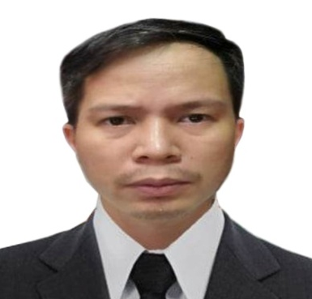

SKILLS

- Microsoft Office
- Photoshop Designer
- CADD Operator
- Forklift Operator
- Backhoe Operator
- Vehicle Operated
  - Motorcycle
  - AT or MT
  - Truck, Van, Bus Etc
  - 4W, 6W, 8W, 10W
  - Trailer Truck
  - Forklift
  - Backhoe
- Driver’s License Code
A,A1,B,B1,B2,C,CE and D

CONTACT

Email:
sirdonlindog@gmail.com
Cellphone No.
+63-956-645-5157
Whattsapp
+63-956-645-5157
EDUCATION

2023
TESDA Short Courses
Automotive Battery Servicing
Diesel Engine Tune up
Articulated Course NCIII
Technical Driving NC II
Dump Truck NCII
Backhoe Loader NCII
Forklift NCII

2005 – 2008
Computer Associate
National College Of Science and Technology
Dasmarinas Cavite

