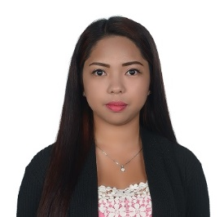
ROCHELLE E. BENEGAS

Phone: 09263900408
Email: rebenegas.nlazap@gmail.com
Address: #98 Dr. Cariño St. Lower Quirino Magsaysay, Baguio City
Birthday: October 04, 1991

CAREER OBJECTIVE
To contribute in the company’s growth by utilizing my knowledge and to gain proficient training to further enhance my skills.

TECHNICAL SKILLS
- Tax reports submitted in BIR
- Microsoft Office (Ms Word, Excel, PowerPoint, Internet)
- Other financial reports needed in banking industry

PERSONAL SKILLS
- Excellent written and verbal communications skills
- Highly organized and efficient
- Ability to work independently or as part of a team
- Proven leadership skills and ability to motivate

EDUCATION
Bachelor of Science in Business Administration Major in Management (2017-2011)
Pamantasan ng Lungsod ng Maynila
Intramuros, Manila

PROFESSIONAL EXPERIENCE
Financial Specialist
NL AZAP Marketing Corp. (December 2017-July 2020)
Provided taxation and financial reports of the company

Assistant Manager
McDonald’s Bonifacio (February 2016- November 2017)
Marketing manager

Accounting Assistant- Loans and Monitoring Department
BDO Unibank, Inc. (August 2011- December 2015)
Provided financial reports and knowledge in foreign currency loans

