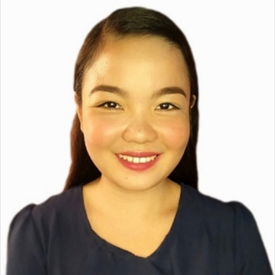 |  | Rowena C. Baradi  🎓EDUCATIONAL BACKGROUND
📍ADDRESS:  #778 Berret Street, Palar Village, Barangay Palar, Taguig City  👤PROFILE  Date of Birth: November 14,1997  Age: 25  Gender: Female  Place of Birth: Bolinao, Pangasinan  Nationality: Filipino  Status: Single  ☎️CONTACT  PHONE:  +639071644500  EMAIL:  rowenabaradi@gmail.com  🗣️Languages  English  Tagalog |  | Tertiary:  Urdaneta City University (2017-2021)  Bachelor of Science in Business Administration  Major in Marketing Management  Secondary:  Dewey National High School (2010-2014)  Dewey, Bolinao, Pangasinan  Elementary:  Dewey Elementary School (2004-2010)  Dewey, Bolinao, Pangasinan  💼Work experience  Bakery Associate / Cinnabon  SM Aura, Taguig City / April 03,2022 – present  - A Baker, Barista and Cashier.  - Providing baked goods to consumers while also providing respectable customer service.  - Ensuring the quality and freshness of all products and services the bakery provides.  - Ensuring proper presentation, food quality, portion control and maintenance of proper serving temperatures.  - Maintaining sanitation of all the equipment, supplies and utensils within work area.  Sewing Machine Operator / Ramrol Garments  Binangonan, Rizal / September 2015 – December 2015  - Sewing Jeans Pants and Perform Quality Checks  Sewing Machine Operator / Janzan Enterprises  Plaridel, Bulacan / February 2015 – September 2015  - Sewing bags, wallet, and etc., and perform quality checks  Factory Worker / Polytex Laiwel Inc.  General Trias, Cavite / January 2015 – February 2015  - Perform quality checks and Packaging finished products.  🤹‍♀️Skills  - Ability to Multitask  - Fast learner  - Ability to work independently or as a part of team  - Effective time management  - Brilliant in performing physical activities  - Good communication skills  I hereby certify that the above the data and information is true  Correct to the best of my knowledge and belief.

