BABY DIANN H. MANALO
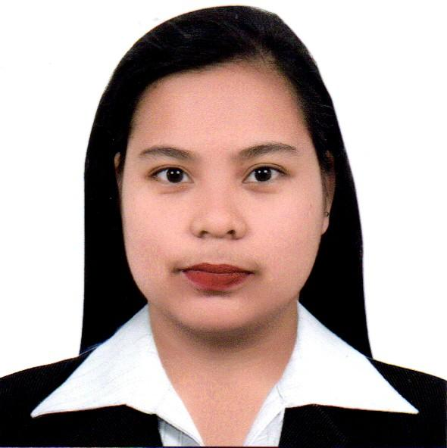  Mobile  +63-919-824-9914  Address  Coral na Munti, Agoncillo, Batangas  Email address  bhabydiannmanalo77@yahoo.com  EDUCATION PROFILE:  Bachelor of Science in Business Administration Major in Financial Management  Batangas State University  Lemery Campus  Rajah Matanda St. Lemery, Batangas  2011-2015  St. Mary’s Educational Institute  Lemery, Batangas  2007-2011  Coral na Munti Elementary School  Coral naMunti, Agoncillo, Batangas  2000-2006  PERSONAL DETAILS:  Gender : Female  Date of Birth: May 24, 1995  Place of Birth: Agoncillo, Batangas  Civil Status : Single  Citizenship : Filipino  Religion : Roman Catholic  Language Spoken:English, Filipino  (Tagalog) | CAREER OBJECTIVE  To fully enhance all the knowledge and skills that I possess and fully apply it in whatever task assigned to me, to become an asset contributing to the advancement and success of the company I am affiliated with.  PROFESSIONAL STRENGTHS  - Computer Literate (Microsoft Office)  - Possesses a good work attitude, flexible and able to work with my colleagues.  - Hardworking, responsible, trustworthy, and patient.  - Good communication skills and leadership skills.  SEMINARS ATTENDED:  TRENDS AND ISSUES ON FINANCIAL MANAGEMENT  Jollibee Diversion, Malinis, Lemery, Batangas  September 27, 2013  BASIC TABLE ETIQUETTE  Max’s Restaurant  Lemery, Batangas  May 17, 2013  ON-THE-JOB TRAINING  - Batangas I Electric Cooperative, Inc.  November to March 2015  WORK EXPERIENCE:  - Membership Clerk I  Caritas Health Shield Inc.  July 06, 2015 to January 2020  - Processing of membership of our client.  - Assisting them regarding to their inquiry.  - Scanning and Printing of their application and policy and ID card.  - Confirmation Assistant  Carehealth Plus Systems International, Inc.  - Answering calls regarding sale verification thru credit cards and debit card.  - Verifying to member if they are aware on plan they availed to us.  - Encoding all the sales we confirm.  - Group Marketing Staff  Carehealth Plus Systems International, Inc.  - Preparing proposal and contracts for our group accounts members.  - Making reports on how many group accounts are closed.  Clinic Staff  Carehealth Plus Systems International, Inc.  - Assisting members regarding teleconsult and endorsing them to the doctor.  - Consolidate on excel files all group accounts APE results.  - Preparing and releasing of the APE results of our clients.  I hereby certify that the above information is true and correct to the best of my knowledge and belief.  BABY DIANN H. MANALO  APPLICANT

