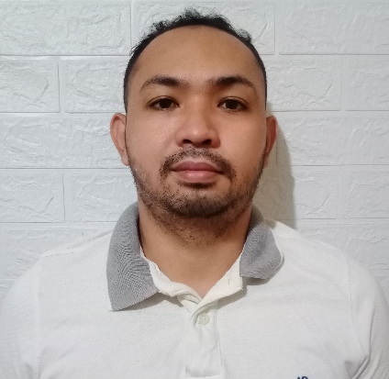
Reizan Luga Mancao
De Guzaman Village km.11 Sasa, Davao City, 8000 Philippines
09369547233
reizanmancao16@gmail.com

Objective
To work harder and pursue a career that will utilize my skills which I obtained a relevant work experiences in line with my personal and academic qualifications and interest.

Skills
- Good Communication Skills
- Willing to take new job and challenges
- Eager to learn

Personal Data

Date of Birth : November 23, 1994
Place of Birth : Davao City
Age : 28yrs. old
Nationality : Filipino
Religion : Roman Catholic
Status : Single
Height : 5’7
Weight : 68Kg

Educational Background
- 2001 – 2007 Vicente Hizon Sr. Elementary School
Barangay Pampanga Davao City
- 2007 – 2011 Francisco Bangoy National High School
Barangay Sasa Davao City
- 2011 – 2013 University of Mindanao Under Graduate
Barangay Matina Davao City

Work Experience

Date : January 31, 2015 to January 31, 2016
Job Title : Merchandiser
Company : Monde Nissin Corporation
Location : Nidea St. Obrero Davao City

Date : August 2, 2016 to September 4, 2018
Job Title : Service Crew
Company : Mcdonalds
Location : Kingdom of Saudi Arabia

Date : August 2019 to March 2020
Job Title : Installer
Company : Mazzini
Location : Matina Aplaya Davao City

Date : January 2021 at Present
Job Title : Auxialiary Production Crew
Company : San Miguel Corporation Multi Services Incorporated
Location : Km.12 Sasa Davao City

APPLICATION LETTER

Dear Ma’am/Sir,

I am Reizan Luga Mancao, under graduate from University of Mindanao I would like to apply for any vacant position in your company commensurate with my qualification. I am very interested in pursuing a career with your organization and I wish to bring my knowledge, skills and experience with excellence to your company. I am enclosing a copy of my resume and transcript of record for your reference and evaluation.

I welcome the opportunity to meet with you at your most convenient time.

Thank you very much and I’ll wait for your favorable response.

Sincerely yours,

Reizan L. Mancao
Applicant

