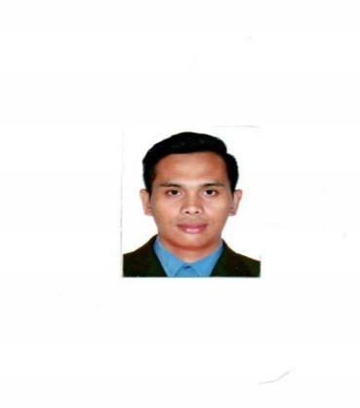
VINCENT UNABIA

Minglanilla City, Cebu Philippines

(+63) 9924573803 ) / unabiavincent8@gmail.com
  - PROFESSIONAL SUMMARY
- Resourceful and Productive with excellence leadership with 10+years of experience in Manufacturing fields. Assessing operational needs and developing solutions to save costs, I want to be part of the company that indulges professional growth which provides challenging and rewarding career while allowing me to utilize my knowledge and skills.
  - SKILLS
- Collaborative team player Honest and Hardworking
- Communication skills Gmp compliance and 5’s implementation
- Efficient and accurate Complex problem-solving
- Handling Machine Assembly semi-conductors
- Equipment Efficiency Quality inspection and Quality Assurance
  - WORK HISTORY
PEGATRON / August 2020-January 2023
Production Worker / Taoyuan City, Taiwan
- Operate various test equipment and tools to perform simple electrical and continuity testing of electronic components, parts and systems. Set-up and operate automatic testing equipment to locate circuit and wiring faults, shorts and component defects. May conduct life tests (burn-ins) on components, sub-assemblies and assemblies.
SHINI PLASTIC’S TECHNOLOGIES / August 2017-August 2020
Production Operator / New Taipei City, Taiwan
- Maintaining processing areas clean, checking product quality, testing samples, maintaining equipment, operating (mini-hydraulic electric forklift) and aligning work pieces. Maintained the production unit by appropriate cleaning and sanitizing. Ensured the quality of the end products. Operated the machines proficiently and checked the product samples.
GENERAL MILLING CORPORATION / June 2012-July 2016
Food processing Packing dept. / Lapu-Lapu City, Philippines
- Determine of Flour or Feeds and supplies to be packaged. Maintained high standards of excellence. Operated numerically controlled equipment used to move products on the assembly line. Inspected ingredients and product to ensure conformance to company specifications.

DELFINGEN / January 2009- January 2011
Production Operator / Mepz2 Basak, Lapu-Lapu City, Philippines
- Monitored machines during operation to detects sounds of malfunction or excessive vibration and adjust machines to eliminate problems. Assessing equipment after each production run and performed preventive maintenance to keep machines running smoothly, followed tooling instruction and product specifications to determine and implement operational sequences.

  - EDUCATION
Mechanical Technology – Vocational / 2007-2009
Don Bosco Technology Center / Labangon City, Philippines
National Technical Certificate

Academic Courses – High School / 2002-2006
University of the Visayas / Minglanilla City, Philippines
High School Diploma

REFERENCES
Available upon request.

