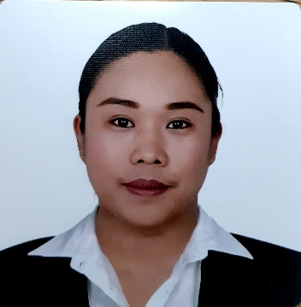
MAUREEN M. FANTOLGO
#99-D 15th Avenue Murphy Quezon City, Philippines
Mobile number: 09124910795
mau_bovic@yahoo.com
maureenfantolgo823@gmail.com

CAREER OBJECTIVES
- To promote the virtues of each company product and assist in making a positive store environment.
- To provide fast and efficient service for company clients
- To find a challenging position to meet my competencies, capabilities, skills, education and experience.

PERSONAL INFORMATION

Nationality: FILIPINO
Resident of: PHILIPPINES
Gender: FEMALE
Age: 35
Date of Birth: JANUARY 05, 1988
Marital Status: SINGLE
UMID#: 0111-18565232
SSS#: 34-2049498-9
TIN#: 409-005-801-000
PASSPORT#: P3043559B
PAG-IBIG#: 121087843403
PHILHEALTH#: 030507480701

WORK EXPERIENCE:

October 17, 2022 – June 28, 2023 Demi Chef de Partie
Holland America Line MS VOLENDAM

October 15, 2021 – July 15, 2022 Demi Chef de Partie
Holland America Line MS NIEUW STATENDAM

October 15, 2019 – July 30, 2020 Apprentice Cook
Holland America Line MS ZUIDERDAM

December 7, 2018 – August 1, 2019 Apprentice Cook
Holland America Line MS NOORDAM

January 4, 2018 – October 13, 2018 Apprentice Cook
Holland America Line MS ZAANDAM

December 4, 2016 – September 28, 2017 Assistant Cook / Commi II
Holland America Line MS ZAANDAM

November 22, 2015 – September 25, 2016 Assistant Cook / Commi II
Holland America Line MS ZAANDAM

July 20, 2014 – May 14, 2015 Assistant Cook / Commi II
Holland America Line MS EURODAM

June 10, 2013 - April 18, 2014 Assistant Cook / Commi II
Holland America Line MS EURODAM

April 25, 20012 - March 18, 2013 Kitchen Assistant / Commis III
Holland America Line MS VOLENDAM

May 2010 – April 2012 Line Cook/ Cold Kitchen
Hotel Rembrandt/ Dinelli Gourmet

EDUCATIONAL BACKGROUND:

Tertiary
2005 – 2010 Bachelor of Science in Hotel and Restaurant Management
World Citi Colleges
960 Aurora Boulevard, Quezon City, Philippines

Secondary
2001 – 2005 Stella Maris College
Cambridge Street Aurora Boulevard, Quezon City, Philippines

Primary
1995 – 2001 Aguinaldo Elementary School
18th Avenue Murphy, Quezon City, Philippines

ACADEMIC EXPERIENCES:

- Linden Suites Hotel (5 star hotel)
Manila
Basic Hotel Management and Operation “Stay and Learn Program”
September 20, 2008

- Bar Exposure Program
T.G.I Friday’s (Tomas Morato, Quezon City, Philippines)
February 19, 2008

- Imperial Palace Suites (3 star Hotel)
Tomas Morato, Quezon City
Hotel Familiarizations and Seminar with Personality Development
September 29, 2007

CHARACTER REFERRENCE
- CHEF EDEN RAMOS
2ND PATISSIER HOLLAND AMERICA LINE
Contact number: 09994505984
Email: edenramos_12@yahoo.com

- MR. MARVIN C. COSTALES
PROFESSOR SHTM
ARELLANO UNIVERSITY – MAIN SALMPALOC, MANILA
Contact number: 09178305878
Email: mackoycostales@yahoo.com

- MR. HERBERT S. DIZON
OFFICE OF THE VICE MAYOR, QUEZON CITY
Contact number: 09174353845
Email: trebreh_hsd@yahoo.com

I hereby acknowledge that all the stated information above is all true and correct.
MAUREEN M. FANTOLGO

