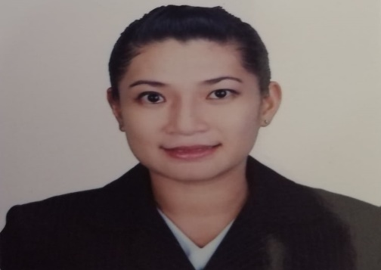
LEVI JEAN DAPROZA DUYAO
LINGSAT, STA. MARIA, ILOCOS SUR
Mobile #: 09309017938/09757071568
Email: levhie.duyao1228@gmail.com

- EDUCATIONAL ATTAINMENT

PRIMARY: BIA-O LINGSAT ELEMENTARY SCHOOL
BIA-O, STA. MARIA, ILOCOS SUR
S.Y. 1994-2000
SECONDARY: SANTA MARIA NATIONAL HIGH SCHOOL
STA. MARIA, ILOCOS SUR
S.Y. 2000-2005
TERTIARY: LORMA COLLEGES
BACHELOR OF SCIENCE IN NURSING
CARLATAN, SAN FERNANDO CITY, LA UNION
GRADUATE STUDIES: UNIVERSITY OF NORTHERN PHILIPPINES
MASTERS OF ARTS IN NURSING (ONGOING) 18 UNITS
TAMAG, VIGN CITY, ILOCOS SUR

- WORK EXPERIENCE

POSITION: CLINICAL INSTRUCTOR (PART TIME)
ILOCOS SUR POLYTECHNIC STATE COLLEGE MAIN CAMPUS
OCTOBER 5, 2022- PRESENT

POSITION: STAFF NURSE (JOB ORDER)
ILOCOS SUR DISTRICT HOSPITAL NARVACAN
NOVEMBER 22, 2017- DECEMBER 22, 2022

POSITION: VOLUNTEER NURSE
JUDGE CELESTINO GUERRERO MEMORIAL HOSPITAL
JANUARY 21, 2010- MARCH 2015

- SEMINARS ATTENDED
- BASIC LIFE SUPPORT
JUNE 24-26, 2022
HEMS ILOCOS SUR PROVINCIAL HOSPITAL- GABRIELLA
- ADVANCE CARDIAC LIFE SUPPORT
SEPTEMBER 14-15, 2022
COMMUNITY AUXILLARY IN RESPONSE FOR EMERGENCY INC.

- 13TH ANNUAL CONTINUING MEDICAL EDUCATION TOUR IN PULMONARY MEDICINE
SEPTEMBER 29, 2018
VIGAN CONVENTION CENTER, VIGAN CITY ILOCOS SUR
- POSITIVE PRACTICE ENVIRONMENT
AUGUST 4, 2018
TADENA HALL UNP, VIGAN CITY, ILOCOS SUR

- PERSONAL DATA

AGE: 33 Y/O
SEX: FEMALE
DATE OF BIRTH: OCTOBER 5, 1989
CITIZENSHIP: FILIPINO
HEIGHT: 5 “4”
WEIGHT: 70 KGS
CIVIL STATUS: MARRIED
SPOUSE: FERNANDO D. DUYAO
FATHER’S NAME: LEONIDO DAPROZA
MOTHER’S NAME: MARCELA DAPROZA
ADDRESS: LINGSAT, STA. MARIA ILOCOS SUR

- CHARACTER REFERENCES

MRS. LOURDES CAMBE
CHIEF NURSE ILOCOS SUR DISTRICT HOSPITAL NARVACAN
09176887952

MRS. MELY JEAN NARTATEZ
NURSE III, ILOCOS SUR DISTRICT HOSPITAL NARVACAN
09177790072

MRS. RIZZA RIGUNAY
NURSE II, ILOCOS SUR DISTRICT HOSPITAL NARVACAN
09175680367

I HEREBY CERTIFY THAT ALL ABOVE INFORMATIONS ARE TRUE AND CORRECT.

LEVI JEAN C. DAPROZA
APPLICANT

