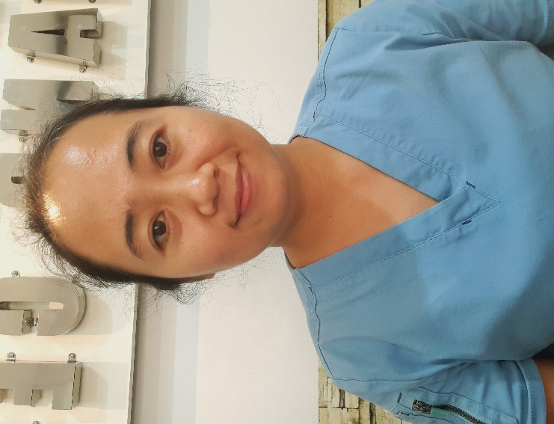 |  | EVANGELINE FIEL LAGMAN  CAREGIVER/ NANNY
Profile  AGE: 34  BIRTHDAY: JANUARY 16, 1989  BIRTHPLACE: APARRI, CAGAYAN  CIVIL STATUS: MARRIED  HEIGHT: 159.5 CM  WEIGHT: 55.5 KG.  CITIZENSHIP: FILIPINO  RELIGION: CATHOLIC  LANGUAGE: ENGLISH, TAGALOG, ILOCANO  PHILIPPINES NURSES LICENSURE EXAM BOARD PASSER (2022)  Contact  PHONE:  +699499367376  +639923031207  EMAIL:  LAGMANEVANGELINE1989@GMAIL.COM  FIELEVANGELINE@YAHOO.COM  FIELEVANGELINE@GMAIL.COM  Hobbies  LISTENING TO MUSIC  DANCING  SINGING |  | EDUCATION  SESELANGEN ELEMENTARY SCHOOL  SESELANGEN, SUAL, PANGASINAN  1995 - 2001  PRIMARY SCHOOL  ST. JOSEPH CATHEDRAL SCHOOL  POBLACION, ALAMINOS CITY, PANGASINAN  2001 - 2005  SECONDARY SCHOOL  GOLDEN WEST COLLEGES  POBLACION, ALAMINOS CITY, PANGASINAN  2007-2011  BACHELOR OF SCIENCE IN NURSING  DEANS LISTER  TERTIARY SCHOOL  WORK EXPERIENCE  CHAN MEI LING (DOMESTIC HELPER)  2012–2017  5 Members of the family. A couple with 3 children. Household chores duty, going to market and budgeting. Nanny duty for youngest child.  HONG KONG  CITY DISATER RISK REDUCTION and MANAGEMENT OFFICE  2022–2023  AMBULANCE CREW  2023-PRESENT  AMBULANCE NURSE  POBLACION, ALAMINOS, CITY, PANGASINAN  TRAININGS
BASIC SWIMMING COURSE + SURFACE WATER SEARCH AND RESCUE TRAINING
JANUARY 24-30, 2022

STANDARD FIRST AID TRAINING AND BASIC LIFE SUPPORT
FEBRUARY 15-18, 2022

