JULIUS C. DOBLAS
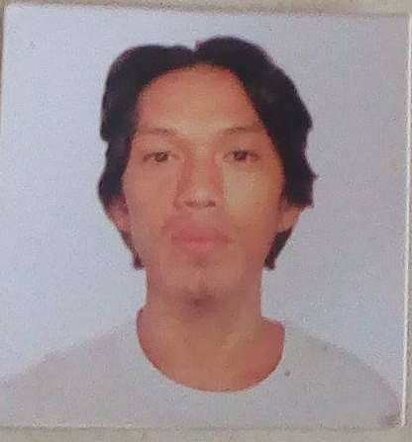
julius.doblas@yahoo.com
09554071349

Objectives: To utilize a position where I can apply my skills and knowledge in a certain company and to promote good interpersonal relationship towards the people in an organization.

Personal Information:

Age: 35
Gender: Male
Civil Status: Single
Nationality: Filipino
Birthdate: October 03, 1986
Birthplace: Mangagoy, Bislig City
Address: St.Niño Guizo, Mandaue City
Religion: Roman Catholic

Educational Background:

Secondary: High School Graduate
Tabon Maximo National High School
Bislig City
2000-2004

Elementary: Elementary Graduate
Mangagoy Annex I Elementary School
Mangagoy, Bislig City
1999-2000

Trainings:

Attended Basic Nihongo Languages Training
(CAPS) Center for Applied Practical Skills at (TESDA) Technical Education and Skills Development Authority
Sampaloc, Manila City
Rendered 300 hours

Attended Bartending
(TESDA) Technical Education and Skills Development Authority
Bislig City
Rendered 3 months

Work Experiences:
* Storage Personnel
Merchandise Distributor Inc.
2018 up to present
* Carpenter (On the Job Call)
2013-2017

* Farmer at Koichi Sasaki
Nagano Ken Japan
2012 ( 1 year)

* Waiter at Cynthia’s Lechon House
Davao City
2005-2006

* Cook at Willie’s Restaurant
Mangagoy, Bislig City
2010-2012
Character References:

Edgar Madelo (Globe Driver) - 09167387366
Edgar Salinas ( Glass Installer)- 09435262899
Randy Balde (Globe Driver)- 09772455151

