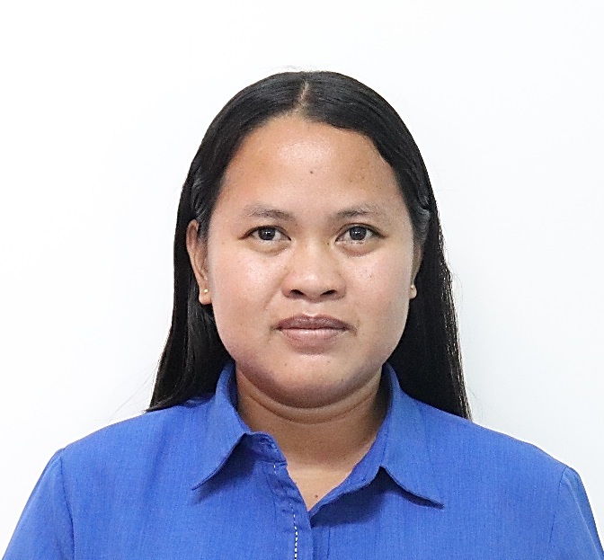
MARICEL A. ALINGAL
+639 502 8767 74/ +639 150 2808 69
Brgy. Bacsil, Bangui, Ilocos Norte
acelantalan_21@yahoo.com/ maalingal@tesda.gov.ph

EMPLOYMENT
BANGUI INSTITUTE OF TECHNOLOGY
Accountant I (Accountant and Budget)
May 5, 2014- Present
- Prepare and submit financial statements and other reports
- Prepare and budget proposals and other related reports
- Monitor and review fund utilizations and disbursements and physical performance of the institution
- Withhold, file and remit taxes for the institution
- Certifies availability of funds in all school programs and projects
- Designated Acting Registrar and BSRS Focal

CITY GOVERNMENT OF MAKATI
Budget Officer II (Administrative Officer IV)
July 1,2023 to December 31,2023
- Review Budget Proposals for assigned offices
- Check Obligation Requests and other supporting documents for claims
- Monitor and review fund utilizations for the assigned offices

SLIMMERS WORLD INTERNATIONAL
Accounting Assistant
February 10,2010- June 30,2013
- Sales audit (contracts, debit/credit card invoices, receipts)
- Conduct spot audit to centers/branches (e.g. cash count for petty cash; internal controls/standard procedures)
- Reconciliation of bank statements against company books
- Other matters as instructed by my superiors

EDUCATION
BANGUI INSTITUTE OF TECHNOLOGY
Trainers Methodology Level I
December 31,2021 to February 5,2022

MARIANO MARCOS STATE UNIVERSITY
Bachelor of Science in Accountancy
2005 –2009

BANGUI NATIONAL HIGH SCHOOL (MAIN CAMPUS)
San Lorenzo, Bangui, Ilocos Norte
Salutatorian
2001-2005

BANGUI CENTRAL ELEMENTARY SCHOOL
San Lorenzo, Bangui, Ilocos Norte
1st Honorable Mention
1995-2001
CAREER OBJECTIVE
To apply for a position which will allow me to utilize and enhance my skills and abilities as well as to acquire experience for continuous professional growth and development.

SKILLS & QUALIFICATIONS

- Proficient in Microsoft Office applications
- Excellent oral and written communication skills
- Have sufficient knowledge in Accounting, Budgeting and Human Resource Management
- Can handle problems and time properly
- Easy to adjust to new environment and easy to deal with all kinds of people in the society
- Ability to work as a part of a team as well as independently with equal efficiency

ELIGIBILITY
Certified Human Resource Associate
Assessment Examination Passer (September 2021)

Bookkeeping National Certificate (NC) III holder (September 2018)

Certified Public Accountant Licensure Examination Passer (November 2010)

REFERENCES
Available upon request.

