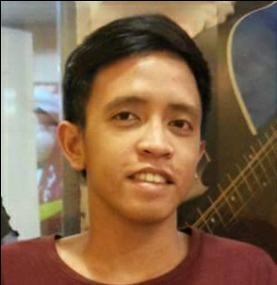
CHRISTIAN JAZEEM R. JOCOY
Middle Nivel Hills Apas, Cebu City
+639152387504
Chanjocs@gmail.com

Summary of Qualifications:

- A highly motivated and responsible individual who can work with less supervision and is willing to be trained
- Has good time management skills
- Knows how to use Microsoft Office Tools
- Can work in a fast-phased environment.

Education:

Senior High School University of Cebu – Main Campus
Sanciangko Street, Cebu City
School Year: 2016-2018

Junior High School Abellana National School
Osmeña Blvd., Cebu City
Year Graduated: 2016

Elementary Lahug Christian School
Gorordo Avenue, Cebu City
Year Graduated: 2012

Personal Details:

Birth Place : Cebu City, Philippines
Birth Date : December 01, 1998
Age : 24 Years Old
Gender : Male
Religion : Catholic
Civil Status : Single
Height : 174

Work Experience

- Stockman
TreeShade Spa, July-Dec 2018
Lahug, Cebu City

- Banquet Server
MarcoPolo Hotel, September 2019 -March 2020
Lahug, Cebu City

- Stockman
S&R Membership Shopping Mall, September 2021 – Febuary 2022
Mandaue City

- Sampling-Team Leader
ActivAsia Inc. March 2022 – Febuary 2023
Banilad, Cebu City

- Installer
ActivAsia Inc, March 2023 – June 2023
Banilad, Cebu City

Character References:

- Andrei Louis Bauzon,
Apas Cebu City
09164844791
Customer Service Representative
- Alfonso Saquilabon Jr.
Apas, Cebu City
09958369161
Customer Service Representative

- Jan Marc Dalapu
Balbarino Subdivision, Butuan City
09231405031
Accounting Clerk

