 | JAIME P. Oclarit  Assistant Cook |  |  | 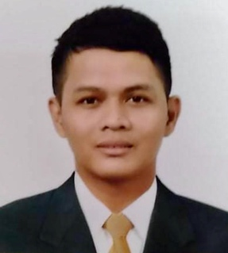
Contact  123 San Andres St. Seacom Compound, Paranaque City  09172467316  ardnekoclarit@gmail.com |  | Objective  To acquire a challenging position in an environment where I can best utilize my skills and experience. And to be able to contribute on your company’s success.
Education  Infotech Institute of Arts and Science, Paranaque City Bachelor of Science in Commerce Major in Computer Science, Undergraduate,  SY 2007-2008  Paranaque National High School, Practical Electricity Vocational Course  SY January – May 2004 |  | Experience  November 2, 2022 – June o5, 2023  COOK • 2nd Cook • GF-3F Bloomingdale Bldg. 205 Salcedo St. Legaspi Makati PHL  Anglo Eastern Crew Management Phils. Inc  August 5, 2021– March 24, 2022  COOK • 2nd Cook • BSM House 1965 Leon Guinto Malate MNL  Bernhard Schulte Shipmanagement  December 5, 2020– March 10, 2021  COOK • 2nd Cook • BSM House 1965 Leon Guinto Malate MNL  Bernhard Schulte Shipmanagement  February 2019 – May 2020  COOK • Assistant Cook • United Philippine Lines Inc.  Holland America Line  October 2014 – December 2018  COOK • LINE COOK • OBS Philippines Corp.  Outback Steakhouse Glorietta 4, Makati Branch  July 2012 – September 2014  Kitchen Staff • Kitchen Prep • Savory Fast Food Inc.  Classic Savory SM Lipa Branch  See below next page for Duties and Responsibilities.
Key Skills  Basic Computer skills (MS Office), English writing and speaking ability, Communication Skills, basic Cooking Skill |  | Character References  Mr. Jayvee Jan Mah Ms. Wendylyn Javier  Restaurant Manager Assistant Restaurant Manager  Gram Café & Pancakes OBS Restaurant Philippines Ltd.  +63-945-294-7278 +63-917-809-8732  Responsibilities (Previous Employment)  Anglo Eastern Crew Management Phils. Inc.  - Working on pantry stations focusing in preparation for salads and dressings, canape, ensuring high quality serving in fruits and cheese combination.  - Ordering produce items to manage weekly stocks for a smooth flow execution.  - To ensure all food served is fresh and well cooked.  - Maintaining cleanliness in station area for the whole shift.  Bernhard Schulte Shipmanagement  - Set-up and stock with all necessary supplies as being supervised by chief cook.  - To ensure all food served is fresh and well cooked.  - Maintaining cleanliness in station area for the whole shift.  Holland America Line  - Line preparation for Sous chef assist,  - Set-up and stock with all necessary supplies as being supervised by sous chef.  - Maintain high quality food for international customers.  - Following brand standards and proper execution.  - Maintain cleanliness in station area for the whole time in cruise.  - Establish and maintain public relations to the foreign co-workers and customers.  Outback Steakhouse Glorietta 4  - Set-up and stock with all necessary supplies  - Prepare food for service, chopping veggies, butchering meat, preparing sauces.  - Cook menu utems in cooperation with the rest of the kitchen staff  - Answer, report and follow executive chef’s instructions.  - Clean up station and take care until the whole shift is done.  - Maintain a positive and professional approach with co-workers and customers.  Classic Savory SM LIpa Branch  - Must maintain safe food handling practices as required by the restaurant.  - Must be able to safety use food service equipment such as grills, fryers, knives, blenders, choppers and oven.  - Responsible for ordering of stocks and daily inventory  - Back up produce items, sauces, and butcher meat for restaurant operation.  - Clean up station before and after shift.

Personal Information

Birthdate: October 17, 1986 Civil Status: Single
Gender: Male Religion: Roman Catholic
Weight: 160 lbs. Height: 5’6”
Father’s Name: Jaime Oclarit Sr. Mother’s Name: Delia Oclarit
Occupation: Carpenter Occupation: Housewife

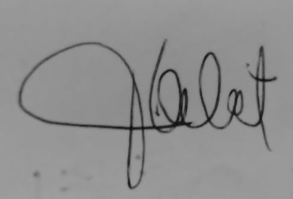 |  | I hereby acknowledge that all information above, mentioned is only the truth and can comply a supporting document as requested.
___JAIME P. OCLARIT__
Applicant Signature

