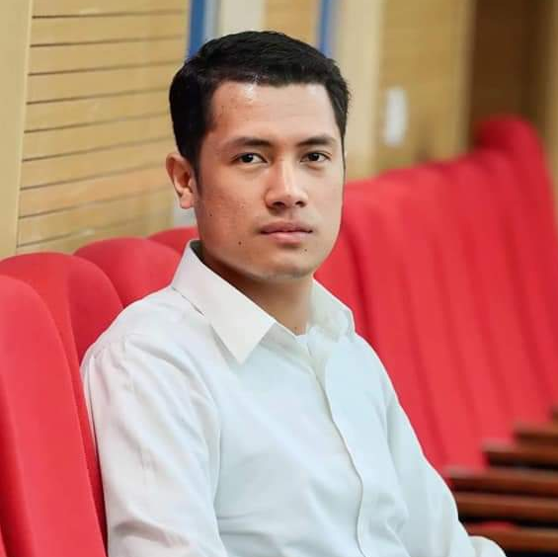

Company : Central Mindanao University
Position : Research Assistant
Date of Employme nt : November 2020 – May 2022

Duties and Responsibilities

Isolate test pathogens, Rear test insect pest, Conduct Pathogenecity Test, Assist in weed samples collection, Conduct bioassays, Assist in verification trials on postharvest commodities, Assist in data gathering and analysis, Performed other functions such as followed up request/communications, prepared Monthly Reports, Document activities of the project.

Company : HEZERA LTD. ISRAEL
Position : Intern/On Job Trainee
Date of Employment : October – November 2022 and.March - September 2023
Duties and Responsibilities

Pollenate and castrate of greenhouse grown bell pepper, tomato and watermelon, Plant care and weeding, Cleaning and sanitize greenhouse.

Company : Pri Or (Mehadrin) Israel
Position : Intern/On Job Trainee
Date of Employment : December 2022 – March 2023

Duties and Responsibilities

Packing of Oranges, Lemon, Citrus, Pomelo and Avocado, Pull out unwanted and unpleasant fruits from the good one.

WORK EXPERIENCE





TRAININGS

TECHNICAL EDUCATION AND SKILLS DEVELOPMENT AUTHORITY
(TESDA) Philippines
Organic Agriculture Production NCII
232 hours

AGROSTUDIES
Agriculture Training/Internship Program in Israel
11 months

JUVAN VILLACURA PIAPE

BACHELOR OF SCIENCE IN AGRICULTURE MAJOR IN CROP PROTECTION (PLANT PATHOLOGY)

PERSONAL INFORMATION

Sex : Male
Age : 26
Height : 5’8
Weight : 73 kg
Civil Status : Single
Birth Date : May 18, 1997
Citizenship : Filipino
Religion : Christian
CONTACT

Address:
P5 Tugaya, Valencia City, Bukidnon, Philippines

Email:
juvanpiape20@gmail.com

Phone number:
055-260-6684
+639358925117

CENTRAL MINDANAO UNIVERSITY (CMU)
University Town, Musuan, Maramag, Bukidnon
Bachelor of Science in Agriculture Major in Crop Protection (Plant Pathology) 2019 – 2020

GUINOYURAN NATIONAL HIGH SCHOOL
Guinoyuran, Valencia City, Bukidnon
2013 - 2014

TUGAYA ELEMENTARY SCHOOL
Tugaya, Valencia City, Bukidnon
2009 - 2010

EDUCATION

QUALIFICATIONS

- Good in Interpersonal Relation, Leadership Skills and Communication Skills
- Computer proficient in MS Word, Powerpoint, and Excel .(basic)
- Facilitating Events
- Flexible and willing to work extended hours and can work with team in a dynamic environment.
- Trustworthy, Hardworking and willing to be trained.

