ARLENE B. HABI
Teacher

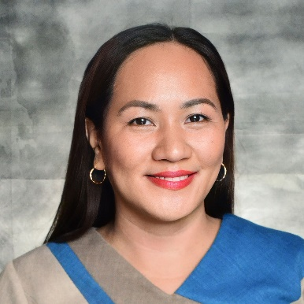
Passionate Teacher with experience developing and implementing
diverse curriculums covering wide range of subjects. Highly skilled at
motivating students through positive encouragement and
reinforcement of concepts via interactive classroom instruction and
observation. Successful in helping students develop strong literacy,
numeracy, social and learning skills. Compassionate, creative and
effective Teacher with valuable experience in classroom
administration, professional development and project planning.
Equipped with extensive background in versatile education
environments. Student-centric instructor, academic facilitator and
motivational coach. Competent at performing independently or as
member of teaching team. Well-versed in classroom and online
Contact

Address
Polomolok, Philippines
Phone
+6399488995167
Email
ahabie1981@yahoo.com

SKILLS

Student- centered learning
Classroom management
Secondary Education
Social- Emotional Learning Training

technologies.
.
Work History

2016-09-Current Teacher II
Palkan National High School
- Graded and evaluated student assignments,
Papers and course work.
- Work cooperatively with others teachers,
Administrators, and parents to help students
Reach learning objectives.
- Kept students on- task with proactive behavior
Modification and positive reinforcement strategies.
- Monitors and evaluates students’ progress
- Undertakes activities to improve performance
indicators
- Maintains updated students school records
- Supports activities of government and non-
Governmental organizations

Education

2015-10/ 2020-03 Master of Education
Major: ENGLISH
Holy Trinity College
General Santos City, Philippines

1998-06/ 2002-03 Bachelor of Secondary Education
Major- ENGLISH
Notre Dame of Dadiangas University
General Santos City, Philippines

