Nikkie Dyan Paloma Cerias 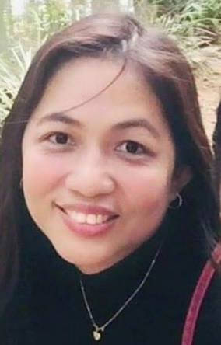
- +639686439018 nikkiedyanpalomacerias

Career Objective: I am looking for a Work from Home Job where I can continually grow as a person and as professional.

Profile
Address: Block 2 Lot 42 Mutual Homes Subdivision, Catitipan, Davao City, Philippines
Birthdate: March 12, 1982
Nationality: Filipino
Languages: English, Filipino

Education

Bachelor of Science in Commerce Major in Management Accounting
Ateneo de Davao University
Davao City
June 1998-March 2002

I took and graduated the course of Bachelor of Science in Commerce Major in Management Accounting. Part of my curriculum was my on-the-job training with the Philippine National Bank in Claveria St, Davao City wherein I was assigned as Assistant Time Deposit Teller.

Public Safety Basic Recruit Course
Philippine National Police Training Service- Regional Training Center 11
Davao City
July 2012-August 2013

I graduated the Public Safety Basic Course which was composed of classroom instructions and Field Training Exercises which is necessary in the Police Service.

Bachelor of Science in Nursing
North Valley College Foundation
Kidapawan City
June 2006-March 2009

I studied Bachelor of Science in Nursing; however, I wasn’t able to complete the course since I need to join the Police Corps before my 30th birthday.

Employment History

Writer/Media Liason
Public Information Office, Police Regional Office 11, PNP
Davao City
November 2019- Present

I write messages, speeches and press releases in behalf of our Regional Director.
I maintain media relation and provide them Press Releases daily.

Secretary
Office of the City Director, Davao City Police Office, PNP
Davao City
April 2017- November 2019

I monitor both the incoming and outgoing messages to and from the office
I keep track and set the schedule of the City Director
I answer telephone call and queries
I entertain clients coming in the office

Researcher
Intelligence Office, DCPO
Davao City
August 2015-April 2017

I am responsible in gathering and analyzing data from the lower units and submit the same to the higher headquarters
I conducted area study and prepare narrative report on the same

Staff Writer
Public Information Office, Police Regional Office 11, PNP
Davao City
December 2013- August 2015

I write messages, speeches and press releases in behalf of our Regional Director and other members of the Command group

Billing Clerk
Kidapawan Doctor’s Hospital
Kidapawan City
June 2005-February 2010

I update patient’s billing chart daily
I prepare their respective ledgers and release their bill prior their hospital discharge
I make monthly reports and consolidation

Stenographer
Internal Affairs Service
Digos City
March 2001- June 2006

I transcribe the Summary Hearing conducted by the Summary Hearing Officer
I provide minutes of meeting and stenographic notes

