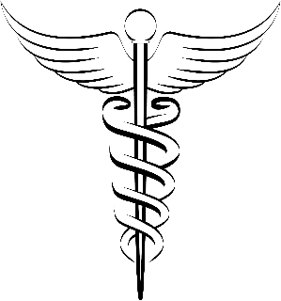
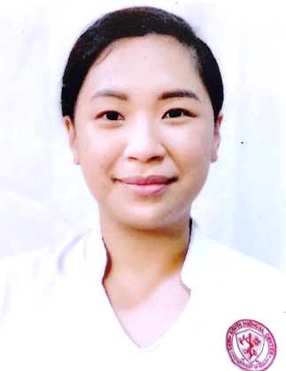
CONTACT

+63933-811-0988
myylanan@gmail.com
Z3 - 813 P. Cañizares St., Dumlog, Talisay City, Cebu, Philippines 6045

EDUCATION

MASTER OF ARTS IN NURSING LEADERSHIP & GOVERNANCE
St. Bernadette of Lourdes College - Quezon City, Manila
2022-present

BACHELOR OF SCIENCE IN NURSING
University of the Philippines –Manila
2003-2008

LICENSE & CERTIFICATION
Passed the 2008 NLE with
PRC license #0514325

BLS and ACLS Certified AHA 2022

PROFILE
Dedicated and compassionate Registered Nurse with 6 years of hospital work experience as a staff nurse in a tertiary hospital; skilled in the assessment, diagnosis, intervention and evaluation in the nursing care of various patients; collaborative team player; accomplished in multi-tasking, a fast learner, and able to work under minimal supervision.
EXPERIENCE

CEBU SOUTH MEDICAL CENTER – San Isidro, Talisay City, Cebu
Staff Nurse - Regular, 2019-present

- Currently managing patients in the Covid Unit (now Communicable Ward) ever since the pandemic started with previous assignment in the Medical Ward and OB Low Risk Ward
- Core member of the Continuing Quality Improvement Team (CQI) that spearheaded the 3M: Modified Medication Management System that decreased medication errors in the Medical Ward in 2020

VICENTE SOTTO MEMORIAL MEDICAL CENTER – Fuente Circle, Cebu City, Cebu
Staff Nurse - Contractual, 2009-2011

- Provided nursing care to patients of various cases in several wards with a 3-month rotation in each area, specifically the Neurosurgical Ward, Orthopedic Ward, Surgical Ward, Labor and Delivery Room, OB-Gyne Ward, Operating Room, Medical Ward, and Private Ward

PHILIPPINE GENERAL HOSPITAL - Ermita, Manila
Student Nurse, 2007-2008

- Worked with staff nurses and served as charge nurse and head nurse at the 7th floor RCB (Right Central Block) Private Ward during my student nurse rotation in the senior year, managing the care for private patients both adult and child

MARIEL THERESA Y. YLANAN
REGISTERED NURSE

