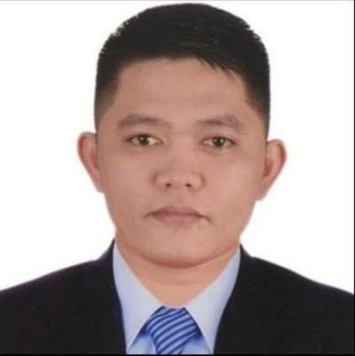
Gilbert H. Caalam
Purok 3 Barangay Espinosa Masbate City
Contact #:09082698688
E-mail Address: bertskiez07.gc@gmail.com

Objective
To be able part of the company/organization where I could use and enhance my knowledge and to gain some experience for successful future achievement.

Work Experience
San Beda College
Mendiola, Manila
(IT STAFF)
(July 16, 2013-December 18, 2013)

Columbia Technologies, Inc.
J. Nakpil Street Malate, Manila
(IT Trainer)
(February 17, 2014-May 17, 2014)

Mother Spice Food Corporation
(IT STAFF
(July 21, 2014-December 31,2015)

Orange Power Network Inc.
South AA Barangay Paligsahan Quezon City
(IT STAFF)
(January1, 2016-Present)-Continues Contract
Atlanta Industries Inc.
Annapolis St. Greenhill’s ,San Juan City
IT Support Coordinator
(July 16-October 31,2021)
Converge ICT Solution Inc.
Reliance IT Building, 99 E. Rodriguez Jr. Ave, Brgy. Ugong Pasig City
Regional Technical Support Engineer
(November 10-Present)
Training/Seminar
Social Security System
East ave. Diliman Quezon City
(On the job Training)
November 22, 2103- February 28, 2013
Professional Skills
- Knowledgeable in Microsoft Office such as; Microsoft Office Power point, Microsoft Office excel, Microsoft Office Word
- Configuring Wireless Router
- Hardware
- Software
- Troubleshooting(Desktop,Laptop,Printer and IP Telephone)
- Installation/Set-up Network
- Basic Photoshop
- CCTV Installation
- POS(Point of Sale)Food and Retail
- Active Directory
- Computer and laptop Hardening
- G-Suit
- Azure Active Directory
- Huawei Switch Configuration using Putty
- Manage Engine management

Personal Information

Nickname : “Bert” Height : 5’2
Gender : Male Weight : 68 kls.
Age : 30 Religions : Catholic
Date of Birth : September 28, 1992 Mother : Ester H. Caalam
Place of Birth : San Fernando Masbate Occupation : House Wife
Civil Status : Single Father : Mateo E. Caalam
Citizenship : Filipino Occupation : Construction Worker
Guardian : Ester H. Caalam
Educational Background

Tertiary : Sorsogon State College Bulan Campus (SSC-BC) 2013-2009
(Bachelor of Science Information Technology)
Secondary : Andres Clemente Jr. High School (ACJHS) 2009-2005
San Fernando Masbate
Elementary : West Elementary School 2005-1999
San Fernando Masbate

Self Actuation
- Willing to undergo over time.
- Capable to do multi-tasking.
- Job fearing

Affiliation
- Infomantech.com Organization
- Student 4Christ Organization

References
Rose E. Ferreras
Campus Administrator
Head
Contact #: 09478908449

Zozimo C. Borlaza
Social Security System Mac Diliman
Team Head
E-mail: borlaza@sss.gov.ph

I hereby certify that the above information is true and correct to the best of my knowledge and belief.

Gilbert H. Caalam Applicant

