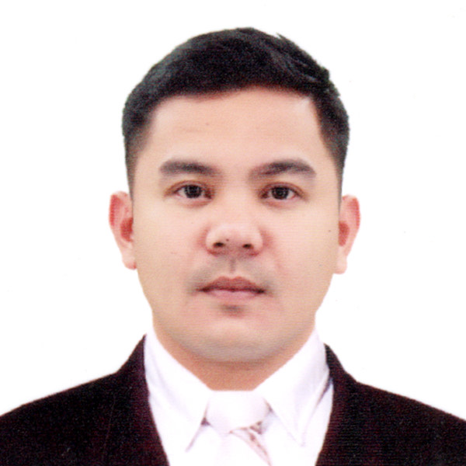

Photo

Dennis, Onofre, Gazmin

Welder
Summary of Qualifications

- Total Years of experience – 10 years
- Years of overseas experience - 4 years
- Welding Process can perform - FCAW, SMAW, MIG, TIG
- Welding positions can perform - Flat, Horizontal, Vertical and Overhead Position
- Type of metals can weld - Steel, Stainless Steel, Aluminum
- Types of Projects worked on - Steel Trusses of house and cover court, Ship building and
attachment the parts Hatch Cover, Muffler, Handlebar, Exhaust Pipe
- Do you have skills in reading/interpreting drawings or diagrams? Yes

PROFESSIONAL EXPERIENCE (from Present to Previous)

Date : October 4, 2018 – August 30, 2022
Position : Welder
Company Name : SANKEI GIKEN KOGYO CO., LTD. ANO FACTORY
Location : Japan, Mie Ken, Tsu Shi
Department : Assembly
Company Website/FB : www.sankei-gk.co.jp
Reason for leaving : End of Contract

Job Description (Welding and/or Fabrication):
- Robot welding process
- Laser Welding Line
- Pipe Bending Line
- Mug Line
- Machine Operator
- MIG
- TIG
Welding experience (company products):
- Laser Welding (Mugs, Tumbler)
- Robot Welding (Motorcycle muffler, Motorcycle Exhaust Pipe)
- MIG (Motorcycle muffler, handle)
- TIG (Motorcycle muffler, handle)

Fabrication experience (company products):
- Roll forming line (Mug, Tumbler, Muffler)
- Pipe bending line (Exhaust Pipe)
- Laser Welding Line (Mug, Tumbler, Muffler)

Welding process and positions can perform:
- 1G
- 2G
- 3G
- 4G

Types of Metals and Welding process used:
- Steel (MIG, TIG, Laser Welding)
- Stainless (MIG, TIG)
- Aluminum (MIG, TIG)

Date : October 24, 2007 to September 2009
Position : Welder
Company Name : Hanjin Heavy Industries & Construction Phil. Inc.
Location : Green Beach 1, Redondo Peninsula, Subic Bay, Freeport Zone, Philippines
Department : Assembly
Company Website/FB : N/A
Reason for leaving : Resigned

Job Description (Welding and/or Fabrication) (at least 7):
- Drilling
- Marking
- Cutting Torch
- Grinding
- FCAW
- SMAW
- Steal Heating

Welding experience (company products):
- SMAW (Container Ship, Bulk carriers)
- FCAW (Container Ship, Bulk carriers)

Fabrication experience (company products):
- Hatch Cover Assemble (Ships)
- Wall Panels (Ships)
- Fit up (Ships)

Welding process and positions can perform:
- Steel, Stainless (FCAW, SMAW)
- Galvanized Iron (SMAW)

Types of Metals and Welding process used:
- High tensile Steel (FCAW)
- Steel, Stainless (FCAW, SMAW)
- Galvanized Iron (SMAW)

TRAININGS AND SHORT COURSES

Course : Welder SMAW NC II
Training Center : TESDA
Location : San Isidro, Tarlac City
Date : October 2, 2016

EDUCATIONAL BACKGROUND

Inclusive Date: October 2, 2016
Course: Welding SMAW NCII
Vocational School: TESDA Training Center
Location: San Isidro, Tarlac City, Philippines

Inclusive Date: SY 2002-2006
Course: Secondary School
High School: Tarlac National High School
Location: San Roque, Tarlac City, Philippines

PERSONAL DATA
Full Name (First, Middle Last) : Dennis O. Gazmin
Nick Name/s : Boy-Boy
Date of Birth : February 19, 1989
Place of Birth : Tarlac, Tarlac
Citizenship : Filipino
Height : 5’5
Weight : 65 kgs
Marital Status : Single
Religion : Roman Catholic
Languages Spoken : Filipino, English, Nihongo
Spouse or Partner : N/A
Children (Name, Sex, Age) : Iah, Female, 7 yo
Cell Number : +639094442302
Landline Number : N/A
Email : dennis.gazmin@gmail.com
Skype ID :
Facebook Name/Email : Dennis Gazmin
Passport Number : P7404214A
Expiry Date : 31 May 2028
Driver’s License (Ph, Int’l etc) :
TIN (Tax Identification No.) : 239657504000
PEOS Certificate No. : JP18-003396

Address
Current : Don Rafael St., San Roque, Tarlac City, Philippines 2300
Home (Philippines) : Don Rafael St., San Roque, Tarlac City, Philippines 2300
Provincial :

In case of Emergency
Contact Name : Christine O. Gazmin
Relationship : Sister
Contact No. : +639993102493

WORK PHOTOS
(Photos while at work, must be wearing proper Personal Protective Equipment)
