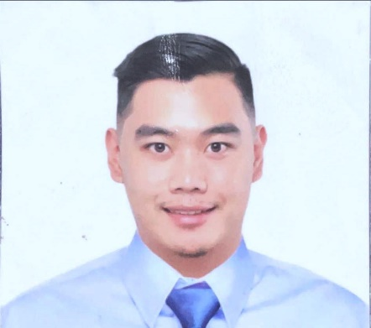
ALDRICH KYLE P. DE GUZMAN
#0867 Green Valley Baguio City
Mobile: 0917 114 3630
E-mail: aldrichkyledgzmn@gmail.com
_____________________________________________________________________________________
Summary:
seeking to join a reputable organization in the tourism industry where I could utilize my earned skills and knowledge with professional commitment to achieve the company’s goal and professional advancement. A challenging work committed to provide my services to the best of my ability, exercise my knowledge and skills to have the opportunity to work as an individual to be able to succeed.
_____________________________________________________________________________________
Academic: University of Baguio
- Bachelor of Science in Tourism Management (December 2015)
_____________________________________________________________________________________
Work Experience:
ACCOUNTING CLERK- LIAISON OFFICER
GOLDRICH CONSTRUCTION & TRADING , Central poblacion, Tuba Benguet
JANUARY 2021- PRESENT
Duties and Responsibilities
-In charge of all related bank transactions
-Pays miscellaneous expenses
-Delivers communication letters to concerned Government and Private Agencies
-Coordinates with the government and Private Agencies with regards to their requirements for the company to meet
-Updates and renews documents, registrations and licenses needed for the operation of the company
-Receives and send parcels to/from the Main Office or Suppliers
-Perform other tasks that may be assigned by the Company
TRAVEL COUNSELOR
Carlson Wagonlit TravelZuellig Building, Makati Philippines
October 2019 – Present
Duties and Responsibilities
- Responsible in making travel arrangement for Corporate Travelers
- Knowledgeable in Airline reservations process such as new booking, exchanges voluntary,
involuntary
- Booking a flight to arranging hotel accommodation
- Knowledgeable in hotel booking policy
- Making car and rail reservations
- Familiar in basic fare tariff and taxes
PASSENGER SERVICE AGENT
Macro Asia Airport Services(Philippine Airlines) NAIA Terminal 2 Pasay City
January 2016 – June 2019
Duties and Responsibilities
- Passenger Handling
- Check in counter agents
- Gate agents
- Arrival agents
- Assists passengers with special needs
- Assists customer before and after flight
- Provides support for other airport personnel
- Dealing with passenger inquiry about flight departures and arrivals
PASSENGER SERVICE DEPARTMENT(intern)
Gulf Air NAIA Terminal 1 Pasay City
August 2015 – December 2015
Duties and Responsibilities
- Provides assistance to Passengers
- Assists in Passenger Boarding , Deplaning and Public Announcements
- Handling Passenger Complaints
- Passenger Handling
Guest Service Officer
Ocean Adventure Park Subic Bay Freeport , Olongapo
June 2015 – August 2015
Duties and Responsibilities
- Brief introduction to guests about the place
- Welcoming guests
- Tour Guiding with the guests
- Explains what are the activities held in the area
_____________________________________________________________________________________
SKILSS:
- Sabre and Amadeus GDS
- Good Communication skills
- Excellent interpersonal skills
- Hardworking and Dedicated
- Ability to work under pressure
- Computer Literate
- English language in verbal and written
_____________________________________________________________________________________Personal Information:
Date of Birth: April 19, 1994
Place of Birth: Baguio City
Nationality: Filipino
Civil Status: Single
Age: 29
Height: 5’10”

