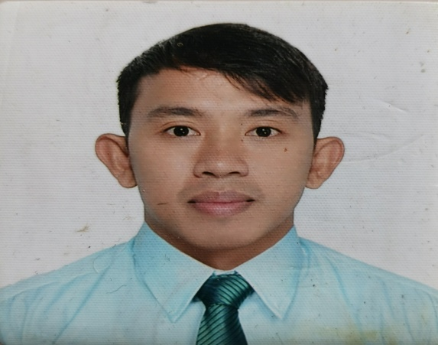

Elmon F. Salazar

Phase 8B Package 1 Block 31 Lot 3 Bagong Silang Caloocan Cities, Philippines.
MOBILE #. +639163671269
G-MAIL: elmonsalazar18@gmail.com

EDUCATION

Bachelor in Public Administration
University of Caloocan City
2012 – 2016

TALA High School
2008 - 2012

Pag-Asa elementary School
2001 - 2007

REFERENCES

KIER RACIMO
DAR OFFICE STAFF
09356527473

Lucky Maon
Restaurant Manager
09163671269

OBJECTIVE

- To obtain any position in any field that would best fit my qualifications and further enhance my values toward any responsibility that I will undertake, develop my talents and skills for continuous career improvement, and excel in every way to tap my potentials making a highly competent, assertive, proactive and creative individual.

WORK EXPERIENCE

Jollibee Lagro
Dining Crew (May 5, 2014 – October 5, 2014)

.
- Monitor every form of service that is being rendered to customers within the restaurant/establishment.
- To give Customer Satisfaction and proper execution of standard that align in company and house rules
- Monitor stock/ inventory and evaluating all materials need to maintain cleanliness of store from exterior to interior.

Jollibee Zabarte
Dining Crew (May 24, 2015 – October 24, 2015)
- Train and evaluating performance newly hired service crew

Jollibee Silang
Dining Crew (January 8, 2016 – April 6, 2016
- Monitor every form of service that is being rendered to customers within the restaurant/establishment.
- To give Customer Satisfaction and proper execution of standard that align in company and house rules

Jollibee Susano Road (WSK Group of Company)
ARM 3 /Dining Manager
(March 3, 2017 - July 31, 2018)
- Facilitate communication between the dining area and the kitchen. Train and supervise front of house staff, enforce dining room policies. Oversee customer service, making sure customers are greeted, their orders taken, and receive proper service.
- Creating secondary task focus on cleanliness to maintain good ambiance of store
- Monitor and liquidate store expenses that according to budget

Jollibee San Bartolome (WSK Group of Company)
ARM 3/ Drive thru (February 1, 2019 – June 30, 2019)
- Training and Monitoring Crew progress
- Insuring all equipment use in drive thru is in good condition
- Monitor proper execution of Food Safety and alagang Jollibee

Jollibee Susano Road (WSK Group of Company)
ARM 3/ Jeds Delivery Manager
(July 1, 2019 – January 15, 2021)

Jollibee Lagro
ARM 3/ Jeds Delivery Manager
(January 16, 2021 – December 31, 2021)

Jollibee Regalado
ARM 3 / Jed Delivery Manager
(January 1, 2022 – August 26, 2022)

- Creating schedule according to aces in their places
- Monitor Motor Bike history, insurance and expenses according to store budget.
- Creating Incentive program for delivery team
- Creating and monitoring customer feed according to their category and create resolution.

Conti’s Baked Shop Restaurant
Restaurant Operation Officer (ROO)
(September 6, 2023 – January 31, 2023)
- Team Member scheduling
- Monitor and evaluating Team member progress

s _______________________

Elmon Salazar

