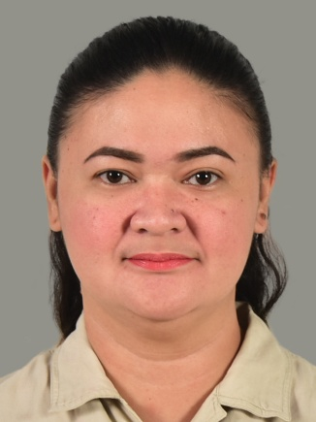
Divina Gracia E. Deliva
110 Conyers Street, Heidelberg, Invercargill 9812
Email: divinagraciadeliva@gmail.com
Mobile: 0274069115
Pharmacy Board Passer as of July 2006

Work Experience

Digos Doctors' Hospital Inc.
(February 2006 – February 2013)
McArthur Highway Tres de Mayo, Digos City Philippines
Position: Staff Pharmacist
Total years of service: 7 years
Davao del Sur Provincial Hospital (DSPH)
(March 1, 2013 - February 7, 2023)
Lapu-Lapu Street, Zone III, Digos City
Position: Pharmacist I

Total years of service: 9 years & 11 months

Trainings

On-the-Job Trnining: Pascual Laboratory (2004)
Balagtas, Bulacan Philippines
Areas Trained: Quality Control, Drug Compounding and Packaging
On-the-Job Training: Digos Doctors' Hospital Inc. (2003)
MacArthur Highway, Digos City
Areas Trained: Drug Dispensing, Pharmacology

Seminars

"Strengthening Pharmacists' Core Values, Enhancing Client Service"
Conducted by: Philippines Pharmacist' Association and UNITED LABORATORIES INC. July 20, 2008 Digos City
"The Role of Regulators and Hospital Pharmacist to Ensure a Proper Direction in Responding to New Challenges"
Conducted by: Philippines Society of Hospital Pharmacist (Davao Chapter) and United
Laboratories in Cooperation with Department of Health
December 5, 2008 Waterfront Insular Hotel Davao City
"Optimum Health Outcomes through Medication Safety"
Conducted by: Unilab Medical and Education Development (UMED)
November 10, 2007, Lotus Court, Marco Polo Hotel, Davao City

Duties and Responsibilities

- Provide all the necessary information needed by the patient and other health care professionals.
- Provide the patient with the optimum drug therapy: right drug of the right patient at the right time and right route of administration.
- Assure the patient on the safe and appropriate use of drugs through application of specialized knowledge and functions in patient care.
- Dispense the required medication needed by the patient as well as advising them on the proper use of all medication, both prescribed and patient-selected.
- Inform the patient on all the possible adverse effects of the drugs as well as its interactions on other drugs.
- Consult with patients to identify symptoms properly in order to advice patient for selfmedication.
- Being involved in the production of drugs and medicines and conduct strict implementation of quality control and quality assurance to assure that medicines produced conform to standards.
- Performs cashiering duties and receiving stocks.

Educational Background

Tertiary:
University of the Immaculate Conception
Fr. Selga Street,-Bankerohan , Davao City
Philippines
June 2001- March 2005
Secondary:
Cor Jesu College High School Department, Sacred Heart Avenue
Digos City, Philippines
June 1997- March 2001
Elementary:
Cor Jesu College Elementary Department, Sacred Heart Avenue
Digos City, Philippines
June 1991- March 1997
Skills

Computer Literate (Microsoft Word, PowerPoint, Excel)
Knowledgeable on drugs (pharmacology, drug interactions)
Can deal with different types of patients and buyers Passed IELTS Exam (band score of 7)
Interests and Attitudes

God- fearing
Loves to work with people and patient
Resourceful Energetic
Responsible
Loves to read and listen to music

Preference

Willing to Travel | : Heavy ( >50%)
Willing to Relocate | : Will Consider
Possess Own Passport | : yes
Availability | : Immediately after notice period of 2 week(s)

Character References

Memolie B. Paculanan, RN, RPH
Head Pharmacist
Davao del Sur Provincial Hospital
(+639955692287)

Vivian Velila, RPh
Chief Pharmacist
Digos Doctors' Hospital Inc.
Digos City
(09224432474)

