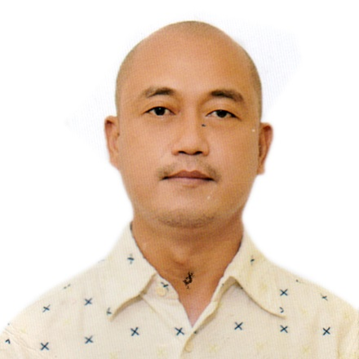

KAISER L. MICLA
Kamias St. Villa Benita Subdivision. Brgy. H.Concepcion, Cabanatuan City, Nueva Ecija
Contact No. 09164585290
kaisermicla@gmail.com

OBJECTIVE:
- To contribute to the success and profitability of the company through my effort, expertise, passion and experience.

EXPERIENCE:

Company : Royal Carribean International
Company Industry : Food and Beverage / Catering / RestaurantPosition / Hotel
Position : Commis 1- Chef De Partie 3
Dept.Duration : Mar 2016 – Nov. 2019
Has worked in different stations such as Specialty Restaurants, Main Dining and Buffet.
In charge in all areas of the station including staffs schedules, daily meetings, preparing checklists of temperatures, food storing and records according to USPH standards and also accountable in performing duties during USPH inspections. Has done all duties assigned.

Job Description :

Company : Pullmantur Cruises Ltd.
Company Industry : Food and Beverage / Catering / RestaurantPosition / Hotel Dept.
Position : 3rd Cook - 2nd Cook
Duration : Oct 2013 - Mar 2016
Has worked in different stations such as buffet and lido whereas duties will serve food in the line and assisting the guests queries at the same time..Has done all duties assigned
Job Description :

Company : Sakae Holdings Ltd Singapore- Nouvelle Events
Company Address : #28 Tai Seng St. Sakae Bldg. Level 7 Singapore 534106
Position : Production Supervisor / Sushi Chef
Duration : Nov. 1, 2010 – June.16 2012
Works in the Sushi production for all major Hotels and Sakae Outlets in Singapore and involved in the quality, consistency and quantities of the product. Following recipes and instructions as per Company’s standard. Prepares checklists of ingredients for Ordering, Receiving and Storing of food items. Responsible for maintaining the cleanliness and sanitation.

Job Description :

Company : Casa Tartufo Ristorante - The Forum Orchard Singapore
Position : Part-time Cook & Kitchen Staff
Duration : May 24-June 14 & Sept.29 – Nov. 12 2012
Job Description :
Assists the Senior Chef in preparation of soups, stocks and sauces. Mise en place of food items such as filleting of fish, Pasta and Breads. Cooking, Frying of Food items.Responsible for taking orders and serving the foods.Responsible for maintaining the cleanliness and orderliness in the kitchen.

Company : PMS Primepower Service
Position : On-call kitchen staff
Duration : Dec. 2009 – Sept. 30 2010
Job Description :
Assists the Senior Chef in preparation of soups, stocks and sauces. Mise en place of food items such as filleting of fish, Pasta and Breads. Cooking, Frying of Food items.
Responsible for taking orders and serving the foods.
Responsible for maintaining the cleanliness and orderliness in the kitchen.
Assists the Senior Chef in preparation of soups, stocks and sauces. Mise en place of food items such as filleting of fish, Pasta and Breads. Cooking, Frying of Food items.
Responsible for taking orders and serving the foods.
Responsible for maintaining the cleanliness and orderliness in the kitchen.

Company Chelsea Market & Café – High-End Restaurant and Fine Dining
Company Address : Serendra, Fort, Bonifacio, Global City, Manila
Position : Commis
Duration : August 2009-Jan 2010
Responsible for preparing some items such as, cooking and serving, preparing roast, sauce, meats, fish and vegetables, and various other foods for serving.
-Lined in different stations like Entree, Grill, fryer, Oven and Expediter.Maintains cleanliness and orderliness kitchen work areas, restaurant equipment and utensils.Done other duties as assigned.

Job Description :

Company : DOF- LGU
Position : Tax Mapper
Duration : Sep 1, 2007 – July 30, 2008

Company : Worldnet Computer Services
Company Address : Fairview, Quezon City
Position : Proprietor / Manager
Duration : Feb 1, 2005 – July 1, 2009

EDUCATIONAL BACKGROUND

May 1998 -May 2004 AMA Computer University Main Campus
Project 8, Quezon City
Bachelor of Science in Business Administration
Major in Management Information System

TRAININGS / SEMINARS:

January 7, 2019 - November 2019 USPH Training Onboard
Certification of onboard core Public Health Training and achieving a score of 90% or higher in the relevant Public Health Test.
May 1, 2016- May 28, 2016 United States Public Health /
Food Safety and Sanitation
Thomas Hunt
Miami, Florida

Aug 1, 2011- Aug 1, 2011 Follow Food & Beverage Safety and Hygiene Policies and Procedures Course
Sakae Holdings Ltd Singapore
LICENSES AND CERTIFICATIONS:

January 2010 - October 2010 Bases des Artes Certificate in Culinary Arts
Certificate in Culinary Arts MOST Institute

Has undergone comprehensive lectures and training in different Cuisines, kitchen knife skills, tools and equipment, HACCP principles, Menu Planning, Recipe Costing, product identification of different food items and cooking methods and techniques.

October 7, 2014 - October 7, 2019 Ship’s Catering Services
National Certificate II
Completed the competency requirements under the Philippines TVET Qualification and Certification System

