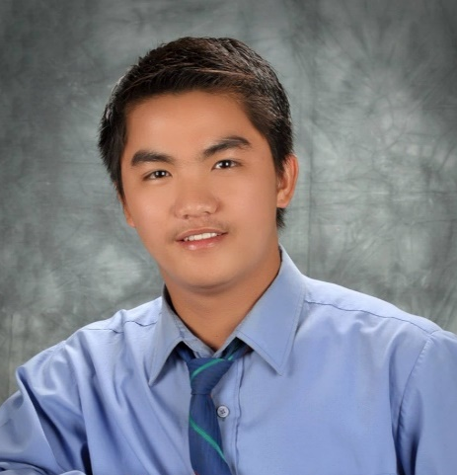

ANTHONY T. ANDONG, RL
PRC Licensed # : 0007476
Cell no.: 09630434456
anthonyandong@yahoo.com
Postal Address:
Buhaw, Puguis, La Trinidad, Benguet

Philosophy:
“Success is not the end, Failure is not fatal; it is the courage that continuous to count.”

Birthdate: May 11, 1991
Birthplace: Kapangan, Benguet
Father: Dally B. Andong
Mother: Nena T. Andong

CURRICULUM VITAE
____________________________________
EDUCATIONAL BACKGROUND
Bachelor of Library and Information Science
Benguet State University, La Trinidad, Benguet
April 2014

Award/s:
Extensionist of the Year 2014

Units in Master of Library and Information
Benguet State University, La Trinidad, Benguet
2018
COMPETENCIES
- Ability to promote reading.
- Ability to present information clearly and in an interesting manner.
- Some public speaking skills may be required as well.
- Strong level of customer service skills.
- Ability to adapt to new tools, systems, and situations as they arise – library and information technology is constantly evolving and shifting, and librarians must be able to evolve along with it.
- Capable of evaluating resources and finding the best ones for addressing different questions or issues.
- Ability to quickly and professionally search databases, internet resources, and catalogs to find needed information.
- Ability to communicate well with library staff as well as with all patrons and guests.
- Must maintain a solid overall understanding of different issues that confront libraries of all sizes.
- Ability to help overcome issues by focusing on solutions instead of on the problems.
- Ability to use technology and to use it to enhance the overall effectiveness of a library, including web-based methods of improving technological access to information.
- Good overall knowledge of archiving and filing information as well as maintaining databases and reference information.
__________________________________________

____________________________________________________________________________

PROFESSIONAL EXPERIENCE
Administrative Assistant II, Benguet Technical School
March 2021 – Present

- Perform general clerical services in the preparation of vouchers, purchase requests, school ID's, etc…
- Facilitate and serve as administrator of the Learning Management System (e-Learning)
- Assist instructors in updating the Learning Management System and creation of accounts for students and instructors

Librarian, Baguio School of Business and Technology
October 2018 – February 2021

- Conducts library orientation to provide information and instruction on the use of library and its resources and services as well as facilitates current awareness services.
- Collects and consolidate purchase requests from Unit/Section Librarians based on available budget and submits final list to the Library Director.
- Supervises data entry of information resources into the Library System.
- Enforces library rules and policies and address costumer issues and complaints.
- Monitors and records patrons and resource utilization statistics on a daily, weekly, monthly and yearly basis. Prepares reports on collection, utilization, activities, accomplishments, and other statistical reports and submit to the Director periodically.
- Administers circulation procedure.

Librarian, Tarlac State University
October 2017 – March 2018

- Conducts library orientation to provide information and instruction on the use of library and its resources and services as well as facilitates current awareness services.
- Collects and consolidate purchase requests from Unit/Section Librarians based on available budget and submits final list to the Library Director.
- Supervises data entry of information resources into the Library System.
- Verifies and Receives equipment/resources from the supply office.
- Enforces library rules and policies and address costumer issues and complaints.
- Monitors and records patrons and resource utilization statistics on a daily, weekly, monthly and yearly basis. Prepares reports on collection, utilization, activities, accomplishments, and other statistical reports and submit to the Director periodically.
- Administers circulation procedure.

Librarian, University of the Philippines-Baguio
July-September 2016

- Enhanced my skills in technical works (accessioning, cataloging, classifying, etc.).
- Administers circulation and inventory procedures.
- Manages information and resources, and helps users locate and utilize information.

Library Practicumer, University of the Philippines-Baguio
November 2013- February 2014

- Enhance my knowledge on selecting materials.
- Improved my technical skills (accessioning, cataloging, classifying, etc.) of books through actual/hands on performance.
- Received and collated books direct from book dealers.

Library Intern, Benguet State University
July 2014- September 2013

- Familiarize the DDC and LC Classifications by performing daily shelf reading.
- Received and collated books direct from book dealers.

EXTRACURRICULAR EXPERIENCE
Comfort Room Cashier and Janitor, Ebes Leasing Services
Magsaysay, Baguio City
May 2014-October 2014

Active member of the Library and Information Science Association (LISA).

Actively participated in some outreach/extension activities of LISA Organization.
______________________________________________________________________

SEMINAR/S ATTENDED
March 27-28, 2023 Seminar-Workshop for Information Officers
SP Conference Hall, Province of Benguet
Nov. 8-10, 2021 31st Library and Information Services (LIS) Month.
October 22, 2021 Practicing COVID-19 Preventive Measures in the Workplace
July 28-29, 2021 Orientation Course for New Employees
Wangal, La Trinidad, Benguet
March 13, 2019 Orientation/Awareness on Emergency Preparedness with Actual Demonstration on Fire Fighting and Search and Rescue
Tarlac State University Gymnasium, Tarlac City
May 10-11, 2018 21st Century Libraries as Collaborative Environments: How Librarians, R Researchers, Teachers, and Extensionists Shape Learning
Seda Vertis North, Diliman, Quezon City

January 12, 2018 Evidence-based Research in Library and Information Practice
University of the Assumption, San Fernando Pampanga

Feb.-March 2015 1st Enrichment Seminar for New Librarians and other Information
Professionals
Department of Related Programs, College of Teacher Education,
Benguet State University- La Trinidad

February 22, 2014 Leadership Seminar
GEMS, College of Teacher Education, Benguet State University

December 6, 2013 Jump Start Your Financial Future
UP, Baguio Library, Baguio City
____________________________________________________________________________

CHARACTER REFERENCES

1.Ms. Maribel A. Helario
Unit Head, TSU Library
Contact no. 09124373360

2.Ms. Brenda A. Dugop
Section Head, University of the Philippine-Baguio
Contact no. 09089042720

3. Ms. Elizabeth A. Lascano
BSU-CTE, BLIS Instructor
Contact no. 09193495940

