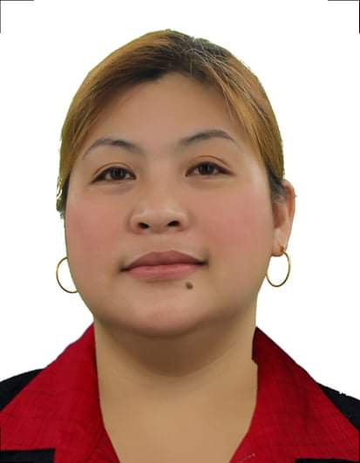
Mary Beth Beltran Ong
309 Romana st. Velasquez st. Tondo, Manila.
Email add: belamo40@gmail.com
Contact no.: 09567168758

Objectives: To be able to work on people-and-goal oriented company that will enable to develop my skill and have career advancement.
_________________________________________________________________________________________
Work Experience:
Bureau of Quarantine Administrative Assistant II January 2022 up to present
- Prepares payroll for job order employees deployed in Manila and Provincial;
- Prepares certificate of employement for job order employesss;
- Prepares payslip and dtr for distribution;
- Prepares and take cares of documents for HEA (Health Emergency Allowance) for job order;
- Prepares and take cares of document for MALASAKIT Program and One Covid-19 (OCA) Allowance;
- Once in a while route documents for signature;
- Performs other related functions as may be assigned.
MGM MOTOR TRADING INC. Marketing Professional February 2021 TO November 2021 (Nissan Manadaluyong Shaw)
- Conducting market research to identify selling possibilities and evaluate customer needs;
- Interacts with potential customers, understands their preferences, demonstrates vehicle
features, facilitates test drives, and assists in completing necessary paperwork for successful sales;
- Actively seeking out new sales opportunities through cold calling, networking and social media.
- Setting up meetings with potential clients and listening to their wishes and concerns.
- Strive to meet sales targets and provide excellent customer service throughout the sales process.

Evolander Motor Corp. Sales Executive August 2010 to June 2012
- Conducting market research to identify selling possibilities and evaluate customer needs.
- Actively seeking out new sales opportunities through cold calling, networking and social media.
- Setting up meetings with potential clients and listening to their wishes and concerns.

Five Star Construction Corp. Project Coordinator March 2004 to 2009
- Maintaining and monitoring project plans, project schedules, work hours, budgets and expenditures.
- Providing administrative support as needed.
- Assess project risks and issues and provide solutions where applicable.

Ay shin Academy Computer teacher May 2001 to March 2004
- Planning lessons and activities that facilitate students' acquisition of basic and advanced computer skills.
- Instructing in a manner that develops students' confidence in their abilities.
- Observing and managing classroom dynamics.

Educational Attainment:

Technological University of the Philippines Bachelor of Science in Industrial Education SY-1997 to 2001
Major in Computer Education w/License
Character References:

Eduardo P. Maderal Jr. Maintenance Supervisor (Kuya J’s Restaurant) 09985889110
Wilma D. Jimenez HR (Bureau of Quarantine) 09175118418
Hazel S. Reyes Sales Manager (Chevrolet and Jetour Edsa Centriz) 09273248830

