MARLON C. MEDINA
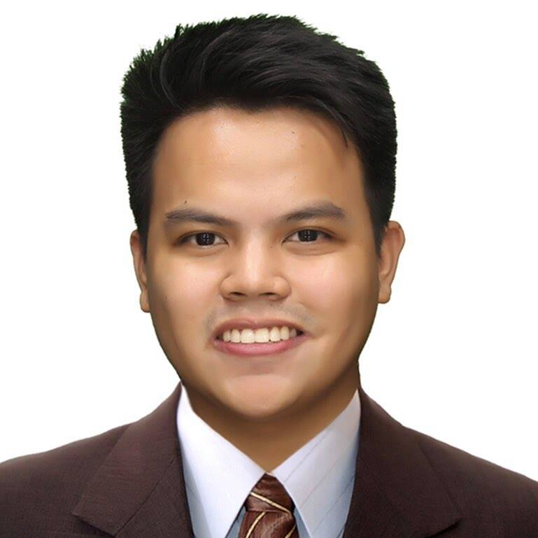
August 4,1994
Fortune, Marikina City, Philippines
+639173145569
marlonmedina045@gmail.com
An encouraging supervisor, analytical problem-solver with talents for team building, leading and motivating, as well as excellent customer relations aptitude and relationship-building skills. Dedicated to applying training, monitoring and morale-building abilities to enhance employee engagement and boost performance.

WORK HISTORY

2023-04- STORE MANAGER TRAINEE
Current Starbucks Philippines, Makati City
- Answered question about store policies and addressed customer concerns.
- Trained new employees on proper protocols and customer service standards.
- Acted with integrity, honesty and knowledge to promote culture of company.
2015-09- SHIFT SUPERVISOR
2023-04 Starbucks Philippines, Makati City
- Resolved customer complaints and issues and offered thoughtful solutions to maintain customer satisfaction.
- Helped store management meet standards of service and quality in daily operations.
- Maintained clean and well organized production areas to avoid food safety issues.
2013-03- CUSTOMER SERVICE CREW
2015-07 KFC, Marikina City
- Worked flexible schedule and extra shifts to meet business needs.
- Operate cash register for cash, e-wallet and credit card transactions with excellent accuracy levels.
- Greeted customers entering stores and responded promptly to customer needs.

RECOGNITION & CERTIFICATION

- Partner of the Quarter consecutive times
- Certified Global Coffee Master
- Certified Barista Trainer

EDUCATION

2009-06- High School Diploma - Valedictorian
2012-03 Dampol 1st National High School, Plaridel, Bulacan

2012-06 Bachelor of Science: Hotel & Restaurant Management
2016-03 ICCT Colleges, Cainta Rizal

