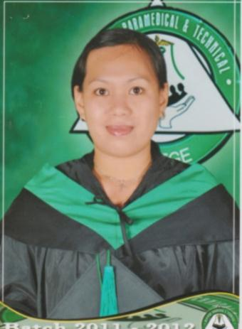

Alexandria S. Farol
Camp6 Kennon Road Tuba, Benguet
2600 Philippines
Contact # : +639274863567
Email Address : alexandriasabong27@gmail.com
Passport # : P7464744A

Objective: To obtain a position as a Spa Therapist in a company that will develop my skills in massage therapy, and where I can provide excellent patient care.

PERSONAL DATA

Age: 36
Gender: Female
Date of Birth: April 02, 1986
Civil Status: Single
Citizenship: Filipino

EDUCATIONAL BACKGROUND

Vocational : Meridian Paramedical and Technical College
April 2011-Sept 2011
COURSE: Massage Therapy
National Certificate 11 (NC11)
December 3, 2014 – December 2, 2019

TRAININGS and CERTIFICATIONS
Basic Life Support/ First Aid and Training

Information Technology Program

Massage Therapy National Certificate 11 (NC11)

Work Experiences

Company: Thai Spa and Traditional Treatment Pvt Ltd
Position: Spa Therapist
Date: Dec.2012 to Dec.2013
Address: Maldives, Hulhumale

Job Description:
- Performing Body treatments like Swedish, Shiatsu, Deep Tissue Massage, Body Stretching, Body Scrubs, and Stone and Bamboo massage, providing massage therapy that soothes muscle, relieves tension, heals soreness, and eliminates stress.
*Swedish Massage is the perfect way for anyone who is overly worked and stressed out to relax their body and mind.
*Shiatsu Massage using thumbs(fingers)pressure help regulate the flow of energy within the body improves circulation.
*Body Scrub will actually help to remove dead skin from your body, making you feel fresh and rejuvenated.
*Stone and Bamboo Massage promotes deep muscle and tissue relaxation, releases toxins, and relieves pain.

Company: Le Monet Hotel
Position: Spa Therapist
Date: April 2015 - December 2015
Address: Ordonio Drive, Camp John Hay, Baguio City

Job Description:
- Provided safe, appropriate and effective massage like Swedish, Shiatsu, Deep
Tissue, and Stone and Bamboo Massage.
*Assessed the needs of each costumer individually and selected the appropriate
treatment.
*Maintained positive guest relations at all times.
*Served costumers quickly while maintaining a cheerful attitude in a high-stress
workplace.

Company: Constellation Ventures Pvt Ltd
Position: Spa Therapist
Date: December 31,2015-April 4,2020
Address: Mathiveri, Maldives

- Job Description
*Guide clients through service offerings and help them choose the types of
massages that would benefit them most.
*Design sessions around client specific complaints or problem areas.
*Listen to clients during massages and adjust technique to meet their needs.
*Take detailed histories from clients, including information about any injuries or conditions such as diabetes.
*Prior housekeeping experience on diving liveaboard.
*Skilled and professional Spa Therapist.
*Experience with the following massage styles; Swedish, Aromatherapy,
Reflexology, Shiatsu.
*Confident in housekeeping, waitress, assistant bar waitress.

Company: Eco Divers Pvt Ltd
Position: Spa Therapist cum Stewardess
Date: August 10,2019–March 11, 2021
Address: Hulhumale, Maldives

- Job Description
*Prior housekeeping experience on diving liveaboard.
*Skilled and professional Spa Therapist.
*Experience with the following massage styles; Swedish, Aromatherapy,
Reflexology,Shiatsu.
*Confident in housekeeping, waitress,assistant bar waitress.

Qualifications
- Able to work well with or without supervision.
- Established good working relationships with guests/costumer.
- Organized, hardworking and detail-oriented
- Proven ability to work cohesively with co-workers as part of the team.

Character Reference

Mr. Amjad Musthafa
(Businessman)
Contact No- +9607774411
Hulhumale, Maldives

Dr.Efren C. Panis
(Meridian School President)
Contact No-(074)445-4170
Baguio City

Bernie McAteer
(Operational Manager of Emperor Maldives)
Contact No. +9607996657
Hulhumale, Maldives

I hereby certify that the above information is true and correct to the best of my knowledge and belief.

Alexandria S. Farol
Applicant

