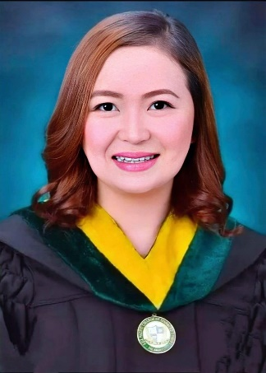

AGNES ARIELLE ALCANTARA SANTE
Home Address: B-3-F FAB Housing Barangay Malaya Mariveles, Bataan
Mobile Number: 0995-756-6343
Email Address: alcantaraagnesarielle11@gmail.com

OBJECTIVES

To build a career that offers challenges and growth with opportunities to enrich my knowledge and skills while
contributing my best to the organization I work for.

ABILITIES

- A good listener communicator who effectively conveys information verbally and in writing. Can speak and understand English and Filipino language.

- Can effectively work under pressure.

- Able to facilitate nurse-client relationship.

- Productive worker, responsible, dedicated, and had a positive attitude for the good performance of my work.

COMPUTER SKILLS

- Knows basic about computer like typing, presentation, and word processing.

- With knowledge at Word, access a Power Point, Internet and E-mail.

- With basic skills such as knowledge in MS-office and Excel along with average typing speed and browsing skills

QUALIFICATIONS

Bachelor Science in Nursing (Graduated Yr.2018)
Practical Nursing (Graduated Yr.2011)

TRAINING HISTORY

Mariveles Mental Hospital
Mariveles, Bataan
Date Coverage: August 23 – September 03, 2010

Bahay Puso Apostolate Foundation Inc.
Address: Sitio Mathay Brgy. Tuyo, Balanga City
Date Coverage: December 2010

RHU (Rural Health Unit)
Address: San Jose, City of Balanga, Province of Bataan
Date Coverage: August – September 2009

NCMH (National Center for Mental Health)
Mandaluyong, Manila
Date Coverage: August 2016

POC (Philippine Orthopedic Center)
Quezon City, Manila
Date Coverage: August 2017

San Lazaro Hospital
Quezon City, Manila
Date Coverage: September 2017

Bataan General Hospital
Address: Tenejero, City of Balanga, Province of Bataan
Contact No. 237-8976

PERSONAL INFORMATION

DATE OF BIRTH: November 11, 1992 AGE: 30

PLACE OF BIRTH: Mariveles, Bataan NATIONALITY: Filipino

SEX: Female CIVIL STATUS: Married

HEIGHT: 5’3 WEIGHT: 55kgs.

EDUCATIONAL BACKGROUND

- ASIA PACIFIC COLLEGE OF ADVANCED STUDIES. Balanga City, Bataan. Bachelor of Science in Nursing. Class of 2018

- CABRINI SKILLS AND DEVELOPMENT CENTER. Balanga City, Bataan. Practical Nursing. Class of 2011

- BEPZ MULTINATIONAL SCHOOL. Fab Mariveles, Bataan. Class of 2009

- BEPZ ELEMENTARY SCHOOL. Fab Mariveles, Bataan. Class of 2005

SEMINARS ATTENDED

- Coronavirus (COVID-19) for Nursing Professionals in Post Acute Care
IntelyCare
April 8, 2020

- Maternal Health Care in the Community
Municipal Health Office
November 19, 2019

- LGU Mariveles Financial Management Seminar
LGU Mariveles at Crown Legacy Hotel Kisad Road Baguio, City
May 22, 2019 - May 24, 2019

- Program Implementation Review and Refresher Course of Standard First Aide and Basic Life Support
Mariveles Rescue Medics LaVista Island Resort Balanga City, Bataan
May 17, 2019 – May 18, 2019

- Nationwide Mass Training on CardioPulmunary Resuscitation
Philippine Heart Association, Inc. Philippine College of Cardiology Council on CardioPulmunary Resuscitation
July 16, 2018

- Bleeding Control Basic v. 1.0 Course
Mariveles Rescue Medics
July 7, 2018

- First Aid Training
Dong-In Sunbirds Corporation
August 11, 2015

- A Must Know About Nursing Documentation Towards Efficient HealthCare Management
Asia Pacific College of Advanced Studies
Date Coverage: September 20, 2012

- Focus on Health Ethics Do’s and Don’ts in Standards Nursing Practice
Asia Pacific College of Advanced Studies
October 9, 2012

- Focus on Medication Nursing: Decreasing Medication Errors
Asia Pacific College of Advanced Studies
October 9, 2012

- Bedside Care Emergencies
Asia Pacific College of Advanced Studies
October 4, 2012

- Basic Life Support and First Aid Training
Mariveles LGU
September 19,2022

WORK EXPERIENCE

- Mariveles Rescue Medics
Municipal Compound Mariveles, Bataan
Medic Nurse
Date Coverage: Yr. June 2018- Up to present

CHARACTER REFFERENCES

Donna Paragas
Senior Nurse
Mariveles Rescue Medics
(+63)970-387-8839

Doctor Gerald Sebastian MD
Municipal Health Officer
Mariveles, Bataan
(+63)915-301-9270

James Russel Matibag RN
Medics Team Leader
Mariveles Rescue Medics
(+63)977-735-6141

I hereby certify that the above information is true and correct to the best of my knowledge.

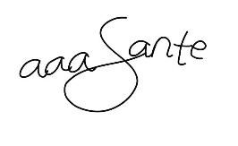

Agnes Arielle A. Sante
Applicant

