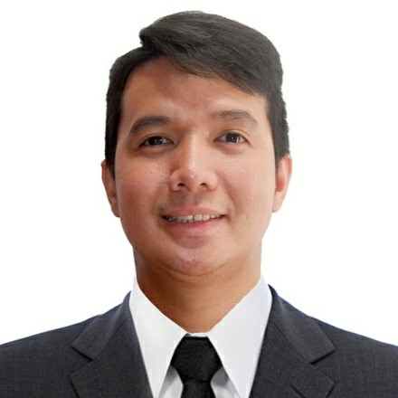
A
t
t
a
c
h
H
e
r
e
2
x
2
C
o
l
o
r
e
d
P
i
c
t
u
r
e
Address: 23 pound st Bankers Village San mateo rizal, Philippines
Mobile No. 09171326622
Email Add: Paniergoronald.1@gmail.com
SUMMARY

As a Waiter more than a year of experience providing excellent service to diners and quality establishments. Familiar with common restaurant equipment and possess ability to upsell alcohol, desserts and appetizers. Looking to leverage my knowledge of the industry for a waiter role at your restaurant.
As a Customer Service Representative, I’ve gained extensive experience across several facets of customer service for having 6 years overall experience in this industry.

WORK EXPERIENCE
Waiter Nov 2022- Present
MARRIOTT HOTEL MANILA
I was assigned as a Waiter, buffet man, food runner, busser, bar, restaurant and banquet server in hotel at the same time serving the guest in VIP Lounge.

Customer Service Representative May 2020 – June 2023
24/7.ai Philippines
I handle Inbound calls from Retail account to provide repair service for home appliances including HVAC unit.

Customer Service Representative October 2019 – May 2020
Telus international
Address: Mckinley West Blvd, Taguig City
I handle Inbound calls from the UBER Transportation Service based in US to provide assistance to the driver about the fare , location , and also about their concern to the passengers.

Customer Service Representative May 2016 – October 2019
Teleperformance
I handle Inbound calls from AvantCard one of the financial account based in the US to provide billing inquiries,refund at the same time escalation for Fraud transaction.

Service Crew May 2014 – May 2016
Mcdonalds
I was assigned as a waiter, kitchen staff at the same time counter staff for order taking to the customers.

TRAINING / CERTIFICATION
Food & Beverages Services
MIHCA (Magsaysay center for Hospitality and Culinary Art Inc.)
GF Pioneer Woodlands Towers 1 & , Edsa, Corner Pioneer St, Mandaluyong City.
July 25, 2022 – Present
PERSONAL INFORMATION
Permanent Address : Blk 5 Lot 13 F. Torres st. Concepcion Uno Marikina City
Birthdate : January 2, 1991
Birthplace : Marikina City
Height : 5’5
Weight : 60kg
Sex : Male
Civil Status : Single
Religion : Born Again (Christian)
Nationality : Filipino

EDUCATIONAL BACKGROUND

School: Concepcion Elementary School
Address: F. Torres st. Concepcion Uno Marikina City 1997 –2003

School: Marikina High School
Address: F. Torres st. Concepcion Marikina City 2003 – 2008

Course: Bachelor of Science in Aviation information Technology 2012 - 2016
School: Philippine State College of Aeronautics Address: Piccio Garden, Villamor Air Base Pasay City
CHARACTER REFERENCES

Ronald S. Del Mundo
Hospitality Instructor (MIHCA)
09275312256
Delmundoronald17@gmail.com

William B. Vidal
Hospitality Instructor (MIHCA)
09293987655
William_vidal@yahoo.com

Ronald Paniergo
Applicant

