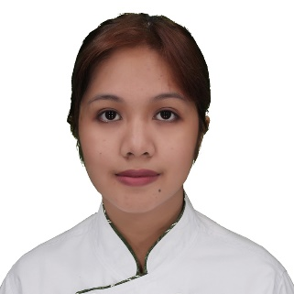
PRECIOUS MAE M. OBEDOZA
#060 Dela Cruz St. Centro, Ramon Isabela, 3319 Philippines (HOME)
Mobile: +63 9677643428
Email Address: preciousmae.obedoza@gmail.com
Skype ID: preciousmobedoza

PERSONAL INFORMATION:

Age: 24yrs old
Birthdate: May 21, 1998
Birth Place: Santiago City, Isabela
Height: 5'2 ft
Weight: 49 kls

CAREER OBJECTIVE:
To be able to acquire a position in your well-known establishment. I believe this would help me widen my knowledge and experience as I take a new journey to a different field and environment.

EDUCATIONAL BACKGROUND:
Bachelor of Science in International Hospitality Management Major
With Specialization in Culinary Arts and Kitchen Operations
Lyceum of the Philippines University (Manila, Philippines)
Dates Attended: June 2014 – June 2018

WORK EXPERIENCE:

Commis 2
Royal Caribbean Feb 5, 2023 to current

Customer Service Representative
Transworld Systems Incorporated (Quezon City, Manila Philippines) Sept 13, 2022- Jan 27, 2023

Kitchen Specialist (cross-trained between bar and kitchen)
UCC Clockwork Midtown (Robinsons, Manila). July 10, 2021 to June 30, 2022

Customer Service Representative
Inspiro Relia(Quezon City, Manila) Sept ,2020- Jan. ,2021

Kitchen Helper
Resorts World Manila (Newport City, Pasay, Manila Philippines) Jan. 17, 2020 - March 17, 2020

Line Cook Nov 2018 – November 2019
Hyatt Regency Houston (Houston, Texas)

Kitchen Trainee Nov 2017 – April 2018
Maikhao Dream Hotels & Resorts (Phuket, Thailand)

Culinary Trainee May – September 2017
Solaire Resort and Casino (Paranaque City, NCR, Philippines)

CERTIFICATIONS AND SEMINARS ATTENDED:
- ServeSafe Certification (Texas) Dec. 06, 2018-December 06,2020
- Integrated Food Safety System (IFSS) July 10, 2017 and July 11, 2017
- Hospitality Professional Certificate (HPC)- March 18,2017
American Hospitality Academy
- ServeSafe Certification March 18, 2017-March 18, 2022
- Seminar on Hotel Operations January 27, 2017
- Restaurant Immersion: Vikings July 21, 2015
- Hotel Immersion: Shangri-La Manila August 11-12, 2014
- TESDA National Certificate III in Events Management Services
- TESDA National Certificate II in Cookery
- TESDA National Certificate II in Front Office
- TESDA National Certificate II in Food and Beverage Services

CHARACTER REFERENCES: Available upon request

