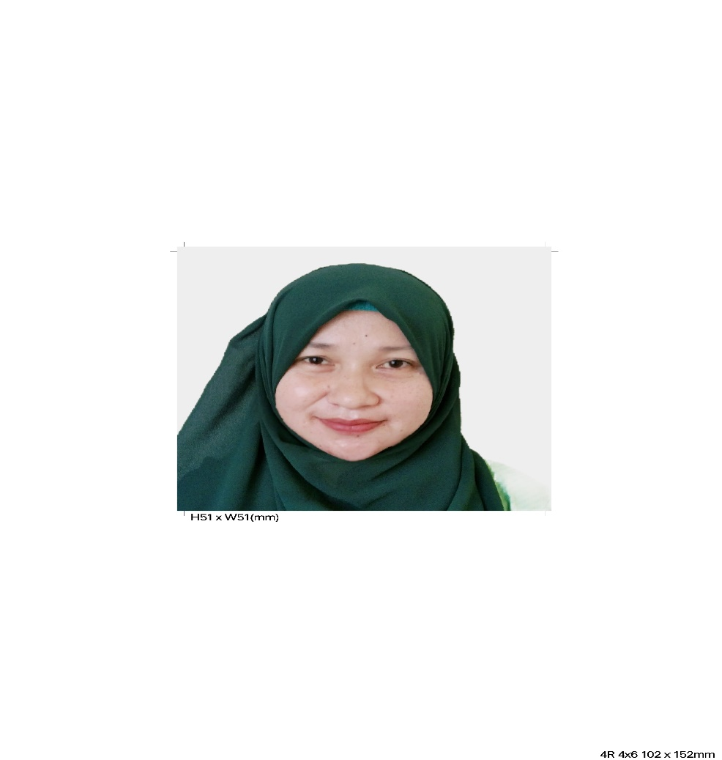

Fatma A. Aunal

Registered Medical Technologist

Crossing Baguindan, Tipo-Tipo Basilan

fatmaaunal84@gmail.com

Contact #:09179179907/09392752512

PERSONAL BACKGROUND

Birthday: October 09, 1985
Age: 37
Place of Birth: Baguindan Tipo-Tipo, Basilan Province
Sex: Female
Status: Married
Religion: Islam

OBJECTIVE

- To gain experience in a new environment
- To strive hard at work and develop friendship with fellow workmates
- To be able to provide the best pre patient caring I can give
- To be able to work in a progressive health care institution, where I can practice and improve my knowledge and skill as a medical technologist

EDUCATIONAL BACKGROUND

COLLEGE: SOUTHWESTERN UNIVERSITY

BACHELOR OF SCIENCE IN MEDICALTECHNOLOGY

Aznar Road. Urgello St. Cebu City

2003-2006

ZAMBOANGA ARTURO EUSTAQUIO COLLEGE

BACHELOR OF SCIENCE IN MEDICAL TECHNOLOGY

BOA San Jose Road Baliwasan, Zamboanga City

2001-2003

HIGH SCHOOL: CLARET SCHOOL OF LAMITAN

Rizal Avenue, Lamitan City

1997-1999

BASILAN NATIONAL HIGH SCHOOL
Leroy S. Brown Isabela City, Basilan
1999-2001

ELEMENTARY: BAGUINDAN PRIMARY SCHOOL

Baguindan Tipo-Tipo Basilan

1991-1993

LAMITAN CENTRAL ELEMENTARY SCHOOL
Lamitan City, Basilan
1993-1997

ACHIEVEMENTS/AWARDS RECEIVED

- Medical Technology Licensure Examination (MTLE) Passer- September 2007

TRAININGS ATTENDED

- Certificate of Cardiopulmonary Resuscitation
CPR Center Tabuk, KSA
May 2009

- Training on Xpert MTB/RIF Assay
RITM Muntinlupa City
July 25-27, 2017

- Capacity Building on Cold Chain Equipment Preventive Maintenance
Kasinnahan Hotel, Isabela City Basilan
November 16-17, 2021

- National Tuberculosis Program Roll Out Training
Isabela City, Basilan
January 18- 20, 2022

- Online Malaria Information System
CT Boulevard Hotel, Zamboanga City
November 7-10, 2022

WORK EXPERIENCE:

- MEDICAL TECHNOLOGIST
Municipal Health Office
Tipo-Tipo,Basilan
August 17, 2015-Up to present

- MEDICAL TECHNOLOGIST (AIDERS)
Department of Health ARMM
July 14, 2014-August 16, 2015

- STAFF MEDICAL TECHNOLOGIST
Juan S. Alano Memorial Hospital INC.
Isabela City, Basilan
February 2, 2011-Up to present

- LABORATORY TECHNICIAN
Ashwaq General Hospital
Tabuk, KSA
December 12, 2009-November 07, 2011

- VOLUNTEER MEDICAL TECHNOLOGIST
Basilan Community Hospital
Isabela City, Basilan
November 11, 2007-August 25, 2009

JOB DESCRIPTION:

- Collect and prepare blood, urine, and tissue samples for analysis.
- Examine collected samples and identify any cell abnormalities.
- Maintain laboratory inventory levels and if necessary, place orders for new supplies.
- Prepare detailed reports about your test results and findings.
- Document and review tested data.
- Ensure all tissue samples are prepped for examination.
- Collaborate with pathologist and other medical specialists to determine correct diagnosis if cell abnormalities are discovered.
- Maintain a safe and clean working environment by adhering to procedures and regulations.
- Present test results to physicians, researchers or patients.
- Maintains professional and technical knowledge by attending educational workshops, reviewing professional publications, participating in professional sociaties.
- Performs all Laboratory examinations requested in Hematology, Chemistry, Parasitology, Clinical Microscopy, Microbiology, Blood Banking and Serology.
- To carry out each test with absolute reliability, accuracy, precision, fair and honesty.
- Performs other related duties.
- Performs all Laboratory examinations requested in Hematology, Chemistry, Parasitology, Clinical Microscopy, Microbiology, Blood Banking and Serology.
- To carry out each test with absolute reliability, accuracy, precision, fair and honesty.
- Performs other related duties
- Performs all Laboratory examinations requested in Hematology, Chemistry, Parasitology, Clinical Microscopy, Microbiology, Blood Banking and Serology.
- To carry out each test with absolute reliability, accuracy, precision, fair and honesty.
- Performs other related duties.

LABORATORY ACTIVITIES:

- Extracts blood from patients at any ward of the hospital and bring it to the laboratory for examination.
- Receives, labels and prepares suitable specimen for examination e.g. urine, stool, sputum, blood and other body fluid.
- Records all laboratory results in the logbook.
- Makes official test results for all examinations performed and submit it to Nurse Station for proper dissemination to attending Physician.
- Do the following in each section:

HEMATOLOGY

MANUAL PROCEDURE:
- Stains blood smears for differential count, malarial smear and peripheral smear.
- Centrifuge capillary tubes for Hematocrit determination.
- Does WBC count, Platelets count, Clotting time, Bleeding time.
- Performs Erythrocyte sedimentation Rate using Wintrobe tube.

MACHINE PROCEDURE:
- Receiving of requests and/ or specimens
- Blood collections
- Celtac ES basic operation and Yumizen H500 operation
- Machine maintenance and troubleshooting (Daily running of controls High, Normal, Low)

- CLINICAL MICROSCOPY
- Examines urine macroscopically (colors, transparency and volume) chemical examination using Insight urinalysis reagent strip, centrifuge urine and examine the sediments microscopically.
- Perform urine Pregnancy test.

- PARASITOLOGY
- Prepares Normal Saline Solution (NSS) for direct fecal smear.
- Examines Fecal Occult Blood.
- Prepares stool for Lactose test.
- Smears an aliquot of stool submitted on slides with NSS and examine microscopically.

- MICROBIOLOGY.
- Fixes, stains slides for Gram staining and Acid Fast Bacilli.

- CHEMISTRY

- Centrifuge blood samples for Chemistry; Separate serum/plasma from whole blood.
- Prepares specimen for send-out when request for particular examinations are not available in the laboratory.
- Re-schedule patient for examination if they not follow strictly the preparation for such examination. e. g FBS(6 to 8 hours fasting) ,FBS and LIPID PROFILE (10 hours fasting)
- Performs RBS,FBS, LIPID PROFILE, BUA, BUN, CREATININE, hbA1C, Trop-T, or any available examination requested.
- Warms up machine before using them.
- BT1500
- SFRI
- ABX PENTRA 400
- Daily run of controls
- Maintains the temperature of the refrigerator where most of the Chemistry reagents are stored.

- IMMUNOSEROLOGY
- Centrifuge blood samples; Separate serum/plasma from whole blood.
- Use of kits(refers to the leaflet of each kit to be used)
- Perform HBV,HAV, Dengue Duo= NS1 antigen/ Igm&IgG, Serum Pregnancy test, Typhi Dot IgM&IgG

- BLOOD BANKING
- Perform Cross-matching
- Collection of patients/recipient’s serum
- Washing of RBC’s
- Perform Blood typing
- Perform Initial phase (NSS)
- Perform Termophase (LISS)
- Perform AntiHuman Globulin phase

REFERENCES

- Nur-khan P. Istarul, MD
- Sitti Hadar A. Hussin, RMT
- Cathy V. Pahalawan, RMT

Signature

